**How to Import a record from ILS (For Chinese, Tamil, Tetum, Thai, Vietnamese, etc)**

1. Log in to ILS database. You can use Account “read” and its password “readread” if you don’t have ILS account.
2. Search a title using keyword search such as LCCN, title, etc.
3. Go to File (main menu) and Save as

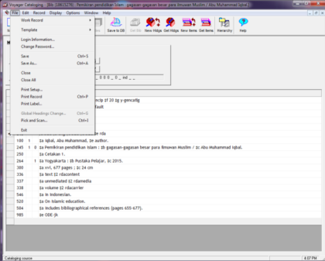

1. Save the record in your document folder as *.bib. For example: 2015323303.bib

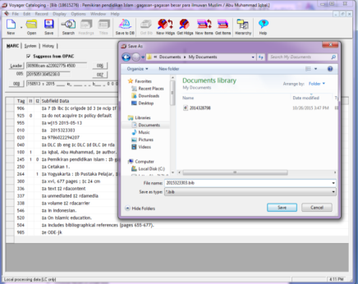

1. Close and go to production database (Virtua)
2. Log in to production database and Open File 🡪 click Records 🡪 click Import Records.

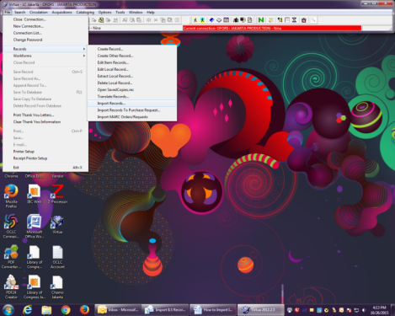

1. Click Reset in small box (Import Records box) and click Yes in Confirm box

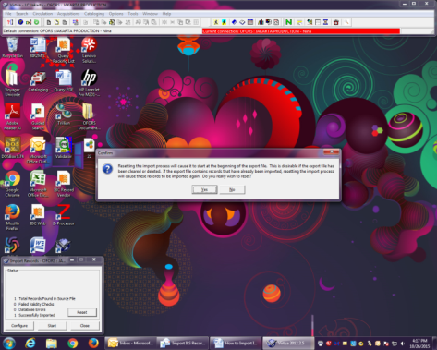

1. Click Configure in small box and open bibliographic record that you have saved from ILS in your document folder.

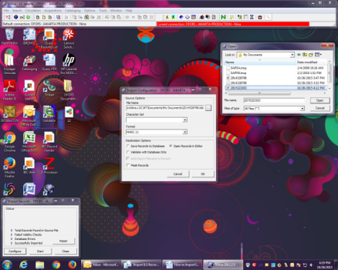

1. Click OK with two options:
   * Save Records to Database or
   * Open Records in Editor.

The second option allows you to edit record before you save it into OFORS Database.

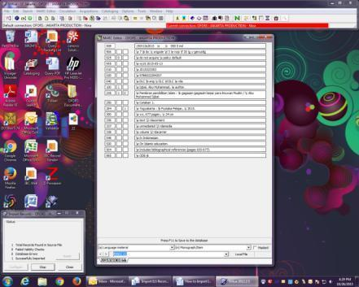

1. Click Start in small box and edit the record if needed --> Go to Marc Editor --> Merge record with Work form and you can continue by adding Profile and tag 998 --> Save to database/F11.
2. Click Stop in small box then close it or you can click Reset for other records.

* **