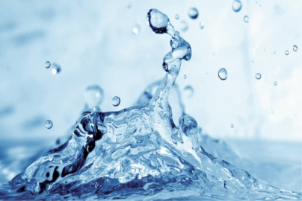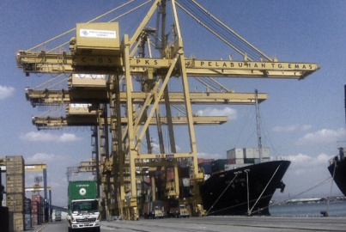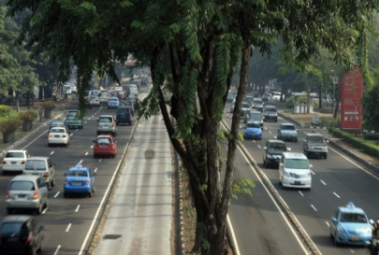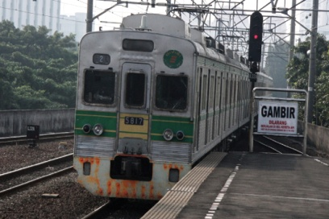
iRAP demonstration project:
technical report

Indonesia Infrastructure Initiative
This document has been published by the Indonesia Infrastructure Initiative (IndII), an Australian Government funded project designed to promote economic growth in Indonesia by enhancing the relevance, quality and quantum of infrastructure investment.
The views expressed in this report do not necessarily reflect the views of the Australian Indonesian Partnership or the Australian Government. Please direct any comments or questions to the IndII Director, tel. +62 (21) 230-6063, fax +62 (21) 3190-2994. Website: www.indii.co.id.
International Road Assessment Programme (iRAP)
iRAP is a charity dedicated to saving lives. iRAP’s vision is a world free of high risk roads. iRAP works in partnership with government and non-government organisations to:
- inspect high-risk roads and develop Star Ratings and Safer Roads Investment Plans
- provide training, technology and support that will build and sustain national, regional and local capability
- track road safety performance so that funding agencies can assess the benefits of their investments.

iRAP is financially supported by the FIA Foundation for the Automobile and Society and the Road Safety Fund.

Acknowledgements
This report was prepared by Greg Smith, Regional Director Asia Pacific (iRAP), Nana Soetantri, Transport Planner (RAA South Australia) and Luke Rogers, Senior Road Safety Engineer (iRAP), who were engaged under the Indonesia Infrastructure Initiative (IndII), funded by AusAID, as part of the iRAP Indonesia Demonstration Project.
The support provided by the staff from Ministry of Public Works’ Institute of Road Engineering and Directorate General Highways, IndII staff and consultants, RAA South Australia and ARRB Group is gratefully acknowledged. Any errors of fact or interpretation are solely those of the authors.

Greg Smith
iRAP Regional Director, Asia Pacific
Jakarta, June 2011

Table of Contents
Acronyms 4
Executive Summary 5
Chapter 1: Introduction 7
AusAID and IndII in road safety 8
The iRAP Indonesia demonstration project 9
Results online 9
Chapter 2: Road Network 10
Chapter 3: Data 11
Road Survey and Coding 11
Traffic volumes 14
Bicyclist (and non-motorised vehicle) volumes 15
Pedestrian volumes 16
Speed 16
Number of deaths and serious injuries 17
Estimated number of deaths 18
Deaths by road user type 19
Number of Deaths and Serious Injuries 19
Economic cost of a death and serious injury 19
Countermeasure costs 20
Discount rate 20
Chapter 4: Detailed Condition Report 21
Chapter 5: Star Ratings 25
Road Protection Scores 25
Overall Star Ratings Results 26
Star Rating Maps 28
Examples of Star Ratings 30
Chapter 6: Recommended Infrastructure Investment 33
Rp 89 billion (US $10 million) Safer Roads Investment Plan 34
Rp 2.9 trillion (US $350 million) Safer Roads Investment Plan 38
Chapter 7: Crash Reduction Investigations and iRAP 41
Purpose of the different approaches 41
Level of risk on the section of Jalan Lintas Pantura Jawa between 3km and 23km north of Tuban 41
Similarities and differences between recommendations 42
How the approaches fit together 45
Chapter 8: Implementation of Countermeasures 46
Roadside hazards 46
Pedestrian crossings 46
Motorcycles 47
Speed management 47
A Safe System 50
Data 50
Background 52
Data Quality Assessment 52
Example Images 54
Recommendation for Training 56
References 66

List of Tables
Table-1: Star Ratings for Jalan Lintas Pantura Jawa 4
Table-2: Road attributes recorded by iRAP 12
Table-3: Pedestrian flow categories 15
Table-4: Reported road deaths on Jalan Lintas Pantura Jawa 17
Table-5: Reported road deaths by iRAP road user category 18
Table-6: Overall Star Ratings 25
Table-7: Total travel by Star Rating 26
Table-8: Overview of the Rp 89 bn (US $10 m) investment plan for Jalan Lintas Pantura Jawa 34
Table-9: Recommended countermeasures in the Rp 89 bn (US $10 m) investment plan for Jalan Lintas Pantura Jawa (costs and benefits over 20 years) 35
Table-10: Overview of the Rp 2.9 trillion (US $350 million) investment plan for Jalan Lintas Pantura Jawa 37
Table-11: Recommended countermeasures in the Rp 2.9 trillion (US $350 million) investment plan (costs and benefits over 20 years) 38
Table-12: Percentage of road rated 1- or 2-stars (out of a possible 5-stars) 40
Table-13: Summary of recommendations made in the CRI and by iRAP 42
List of Figures
Figure 1: The iRAP protocols 6
Figure 2: The iRAP road survey, coding, Star Rating and Safer Roads Investment Plan process 7
Figure 3: The iRAP road network: Jalan Lintas Pantura Jawa (or AH2) 9
Figure 4: Hawkeye Processing Toolkit used for coding survey data 11
Figure 5: Annual Average Daily Traffic (AADT) 13
Figure 6: Bicyclists and non-motorised vehicles on A. Yani – Sudirman - Kota 14
Figure 7: Bicyclist and non-motorised vehicle flows per day 14
Figure 8: Speed sampling results (sample size ~100 vehicles) 16
Figure 9: Road conditions for Jalan Lintas Pantura Jawa 20
Figure 10: Casualty crash rates and curve radius 24
Figure 11: Road Protection Scores for motorcyclists on the Batas – Tegal section 25
Figure 12: Star Ratings for vehicle occupants 27
Figure 13: Star Ratings for motorcyclists 28
Figure 14: Star Ratings for pedestrians 28
Figure 15: Star Ratings for bicyclists 29
Figure 16: Deaths and serious injuries prevented map (Rp 89 billion / US $10 million plan) 36
Figure 17: Deaths and serious injuries prevented map (Rp 2.9 trillion / $350 million plan) 39
Figure 18: Sketch of CRI and iRAP (in green) recommendations 43
Figure 19: Exclusive motorcycle lanes have been used to good effect in Malaysia 46
Figure 20: Motorcyclist Star Ratings with different travel speeds 47
Figure 21: The 100m sample road 48
Figure 22: Changes in RPS and Star Ratings as a result of design and speed changes for the section of road shown in Figure 21 48
Annexes
Annexe 1: Road Survey Data Quality Review 51
Annexe 2: iRAP Road Attributes 56
Annexe 3: Countermeasure Costs 61

Acronyms
AADT | Annual Average Daily Traffic
AusAID | The Australian Government’s overseas aid program
DGH | Directorate General Highways
IndII | Indonesia Infrastructure Initiative
iRAP | International Road Assessment Programme
IRE | Institute of Road Engineering
KSI | Killed and serious injury
RPS | Road Protection Score
WHO | World Health Organisation
vpd | Vehicles per day

Executive Summary
The World Health Organisation estimates that 37,438 people were killed on Indonesian roads in 2007, 61% of whom were motorcyclists (WHO, 2009). With economic activity in Indonesia growing at more than 6% per annum, there is a very serious risk that road trauma will increase unless mitigating measures are put in place.

To help reduce the risk of deaths and serious injuries in Indonesia, iRAP was invited by AusAID, through the Indonesia Infrastructure Initiative (IndII), and the Directorate General of Highways (DGH) to undertake a demonstration project. The project assessed infrastructure risk on 836km of Jalan Lintas Pantura Jawa (the North Coast Corridor in Java), producing Star Ratings and economic assessments of road safety countermeasure options.

It is estimated that 6,897 people are killed or seriously injured on this section of Jalan Lintas Pantura Jawa each year, at a cost of US$550 million to the economy. Nearly three-quarters of people killed are believed to be motorcyclists.

The infrastructure risk assessment, which was based on detailed survey data and coding of 50 road attributes at 100 metre intervals along the corridor, found that a significant percentage of Jalan Lintas Pantura Jawa is rated 1- or 2-stars (out of a possible 5-stars), which indicates a high level of risk. As the table below shows, almost half the corridor (43%) is rated 1- or 2-stars for motorcyclists. Nearly three quarters of the corridor is 2-star for pedestrians (72%), and two-thirds (66%) is 2-stars for bicyclists. 17% is 1- or 2-star for vehicle occupants.
Table-1: Star Ratings for Jalan Lintas Pantura Jawa
Road user type | Length (km)
Vehicle occupants | 836 | 2% | 15% | 34% | 36% | 14%
Motorcyclists | 836 | 11% | 32% | 26% | 29% | 2%
Pedestrians | 836 | 0% | 72% | 28% | 0% | 0%
Bicyclists * | 836 | 0% | 66% | 14% | 9% | 0%
* 12% of roads did not have bicycle traffic and were not star rated.

Although 31% of the corridor is rated 4- or 5-stars for motorcyclists, 43% of motorcycle travel occurs on these roads, which tend to be in urban areas where infrastructure provision is reasonable (including median barriers) and speeds are relatively slow. A third (34%) of motorcycle travel occurs on 1- and 2-star roads.

Pedestrians and bicyclists tend to be over exposed to heavy traffic volumes. 41% of motorized vehicle travel occurs on roads that have high pedestrian traffic and no footpaths or pedestrian crossings; 44% of motorized vehicle travel occurs on roads that have high bicycle flows and no bicycle facilities.

Two Safer Roads Investment Plans were generated for the corridor, each of which identifies economically viable infrastructure safety countermeasures:
- An investment of Rp 89 billion (US $10 million) would prevent 142 deaths per year, which represents a 23% reduction. Over 20 years, this investment would save Rp 14,000 billion (US $1.6 billion) in costs associated with deaths and serious injuries.

- An investment of Rp 2.9 trillion (US $350 million) would prevent 313 deaths per year, which represents a 50% reduction. Over 20 years, this investment would save Rp 31,000 trillion (US $3.6 billion) in costs associated with deaths and serious injuries. This plan is based on all countermeasures that achieve a benefit cost ratio of greater than 1.

The plans focus on:
- reducing the likelihood and severity of run-off road crashes by widening shoulders and clearing roadside hazards
- reducing risk at intersections through grade-separation and signalization
- reducing risk for motorcyclists by providing dedicated motorcycle lanes
- reducing risk for pedestrians and bicyclists through the installation of bicycle lanes, footpaths and crossings.

In interpreting the results of this report, it is important to recognise that iRAP is designed to provide a network-level assessment of risk and cost-effective countermeasures. For this reason, implementation of the proposals in this report will ideally include local examination of proposed countermeasures; preliminary scheme investigation studies and detailed design and costing of each proposal; final evaluation and then construction. Crash Reduction Investigations (CRI), which have been undertaken by IndII, provide an excellent basis for transforming iRAP recommendations into designs and construction.

The digital image surveys of the Jalan Lintas Pantura Jawa and access to detailed results and data on iRAP’s online software have been made available to stakeholders for further exploration and use.

- Introduction
iRAP was established to help tackle the devastating social and economic cost of road crashes. Without intervention, the annual number of road deaths worldwide is projected to increase to some 2.4 million by 2030. The majority of these will occur in low-income and middle-income countries, which already suffer nine out of ten of the world’s road deaths. Almost half of those killed will be vulnerable road users – motorcyclists, bicyclists and pedestrians.

The World Health Organisation estimates that 37,438 people were killed on Indonesian roads in 2007, 61% of whom were motorcyclists (WHO, 2009). With economic activity in Indonesia growing at more than 6% per annum, there is a very serious risk that road trauma will increase unless mitigating measures are put in place.

Large as the problem is, making roads safe is by no means an insurmountable challenge; the requisite research, technology and expertise to save lives already exists. Road safety engineering makes a direct contribution to the reduction of road death and injury. Well designed intersections, safe roadsides and appropriate road cross-sections can significantly decrease the risk of crashes occurring and the severity of crashes that do occur. Dedicated footpaths and bicycle paths can substantially cut the risk that pedestrians and cyclists will be killed or injured by avoiding the need for them to mix with motorised vehicles. Dedicated lanes for motorcyclists can minimise the risk of death and injury for this class of road user.

By building on the work of Road Assessment Programmes (RAP) in the developed world (EuroRAP, AusRAP and usRAP) and with the expertise of leading road safety research organisations worldwide, including ARRB Group (Australia), TRL (United Kingdom), the Midwest Research Institute (United States) and MIROS (Malaysia), iRAP has developed four globally-consistent protocols to assess and improve the safety of roads (see Figure 1).
Figure 1: The iRAP protocols
- Risk Maps use detailed crash data to illustrate the actual number of deaths and injuries on a road network.
- Star Ratings provide a simple and objective measure of the level of safety provided by a road’s design.
- Performance Tracking enables the use of Star Ratings and Risk Maps to track road safety performance over time and establish policy positions.
- Safer Roads Investment Plans draw on approximately 70 proven road improvement options to generate affordable and economically sound infrastructure options for saving lives.
To help reduce the risk of deaths and serious injuries in Indonesia, iRAP was invited by AusAID, through the Indonesia Infrastructure Initiative (IndII), and the Ministry of Public Works, specifically Directorate General of Highways (DGH), to undertake a demonstration project. The project involved using iRAP protocols 2 and 4 to assess infrastructure risk on Jalan Lintas Pantura Jawa, for which road survey data had already been collected.

The production of Star Ratings and Safer Roads Investment Plans involves a number of steps, as illustrated in Figure 2. The iRAP assessments make use of road attribute data for 50 variables at 100 metre intervals along a road. Thus, the data collection task is large; in this project a total of 418,000 data points were recorded. This data was compiled through road surveys that collect digital images of the road multi-view high-resolution cameras as it is driven. After the images were collected, they were viewed by coders using specialised software in the office to record the road attributes.
Figure 2: The iRAP road survey, coding, Star Rating and Safer Roads Investment Plan process
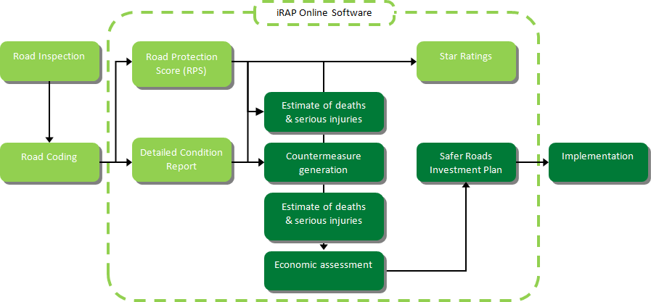

AusAID and IndII in road safety
An initial (2008) investigation of possible AusAID Road Safety Projects in Indonesia identified the following priority issues for attention:
- lack of leadership by government in addressing the management of road safety at a national level in a meaningful way;
- inadequate assessment and identification of the key road safety problems, including limited scope of road safety policies, standards and guidelines;
- limited crash investigation and reporting systems;
- institutional settings which are currently characterised by a lack of a clear road safety results’ focus, very weak institutional operational capacity; and
- the current road safety funding model is not adequate, actions taken to improve road safety are limited, and previous efforts to improve national capacity have been fragmented.

Following the initial study, IndII has provided support for the establishment of a Road Safety Engineering Unit (RSEU) in DGH, and for the preparation of a Road Safety Audit and Crash Reduction Program. Assistance by IndII to DGH to produce Road Safety Manuals and Audio Visual Aids is also proceeding.

The iRAP Indonesia demonstration project
The iRAP Demonstration Project in Indonesia, was undertaken in partnership with the Directorate General of Highways (DGH). Its terms of reference were:
- assess risk on approximately 1,000km of highways and preparing ratings and plans;
- build knowledge and awareness of road infrastructure safety and iRAP in Indonesia; and
- develop recommendations for a potential large-scale, sustainable road assessment program in Indonesia.

This Technical Report focuses on the first and second of these dot points. It is complemented by a separate report, the iRAP Indonesia Strategy: Decade of Action for Road Safety 2011-2020, which focuses on the third point.

Results online
This report provides an overview of the results produced in the project. Full results, including summary and detailed results tables, interactive maps and data underpinning the analyses, are available in the iRAP online software at www.irap.net. The online software also contains the iRAP Road Protection Score (RPS) and Star Rating Demonstrator.

Access to these results is available to DGH, IRE and IndII staff, using the following details:

- Username: indonesia.demonstration
- Password: indii270511
- Road Network
The demonstration project focused on Jalan Lintas Pantura Jawa in Java (also known as the North Coast Corridor). This corridor has a total length of approximately 1,300km and was selected because:
- it is a strategically important part of Indonesia’s transport network
- it carries significant volumes of traffic is in known to be the location of serious crashes
- road survey data has already been collected
- road safety audits, black spot analyses and limited improvements have been undertaken on this road. As such, it provides a strong basis for comparing the iRAP results with work already undertaken
- a significant proportion of the Jalan Lintas Pantura Jawa is designated as Asian Highway 2 (AH2), as shown below in Figure 3.

Figure 3: The iRAP road network: Jalan Lintas Pantura Jawa (or AH2)

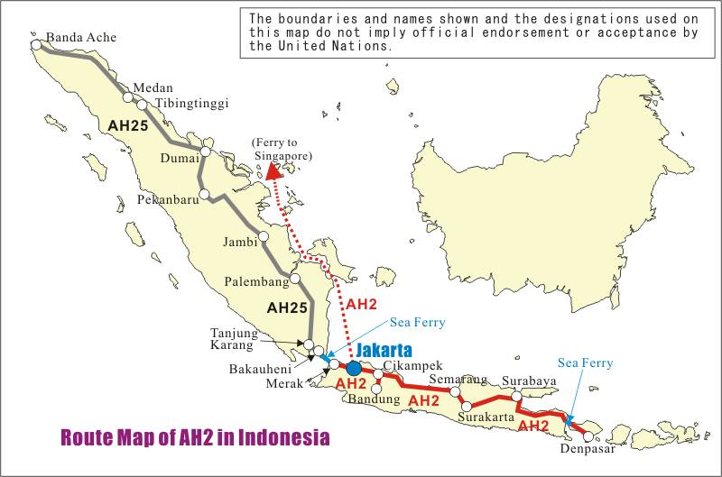

In this project, the assessment was limited to 836km, which is less than the entire length of Jalan Lintas Pantura Jawa. This reduction relates to the quality of survey data available (see Chapter 3).

- Data
The iRAP analyses are based on a combination of data relating to road attributes (which primarily contribute to the risk assessment and Star Ratings) and background data, such as traffic volumes, road deaths and economics (which primarily are used in the Safer Road Investment Plan analyses). The background data plays an important part in the calibration of fatality estimates to reflect local conditions. More information on the iRAP Methodology and how data is used is available in:
- Star Rating Roads for Safety: The iRAP Methodology
- Safer Roads Investment Plans: The iRAP Methodology

Each of these is available for download at www.irap.org/library.aspx.

Road Survey and Coding
Road survey data had already been collected by the Ministry of Public Works’ Institute of Road Engineering (IRE) using an ARRB Group Hawkeye system which is accredited by iRAP. This data was supplied to iRAP for this project. This data was collected between 2009 and 2010, and includes:
- digital images for at least 20 metre intervals
- GPS coordinates
- distance measurements.

Although digital images have been captured with two cameras only (as opposed the three, which is the iRAP preference), and an initial review of the data by the ARRB Group coding team showed that this was sufficient for the demonstration project. However, the team found that not all the data provided was able to be used for the project. As a result, the total length of the assessment was reduced slightly, to 836km. The key issues identified by ARRB Group in relation to data quality were:
- there were instances where the survey data had continued to be collected once the lighting conditions become poor in the late-afternoon, meaning road attributes were not sufficiently visible for coding
- in other instances the images were too bright, meaning road attributes were not sufficiently visible for coding
- the images had been calibrated for on-screen measurements, although it is difficult to comment on the accuracy of the calibrations except to say that the measurements appear to be reasonable. Proper documentation of the calibration process used for collection of the survey data would improve certainty about the measurements
- the data set contained many bad surveys. This includes runs that had been aborted just after the start and runs that only contained one reference point. In some instances the imaging data was missing and on other occasions the geometry data couldn’t be processed because there wasn’t enough lead-in data
- the inclusion of a third forward facing camera to give a better panoramic view of the road would make a dramatic improvement to the coding task.

ARRB Group recommended that the survey team at IRE would benefit from training in:
- system calibration
- survey planning
- data collection techniques
- data handling.

The Survey Data Quality Review report can be found in Annexe 1.

The survey data was coded according to the iRAP Inspection Manual by an experienced ARRB Group team. Figure 4 is a screenshot from the ARRB Group Hawkeye Processing Toolkit which was used to code the road attributes, and Table 2 provides a summary of the attributes that are recorded in iRAP projects (the complete list of road attributes is provided in Annexe 2).

Figure 4: Hawkeye Processing Toolkit used for coding survey data

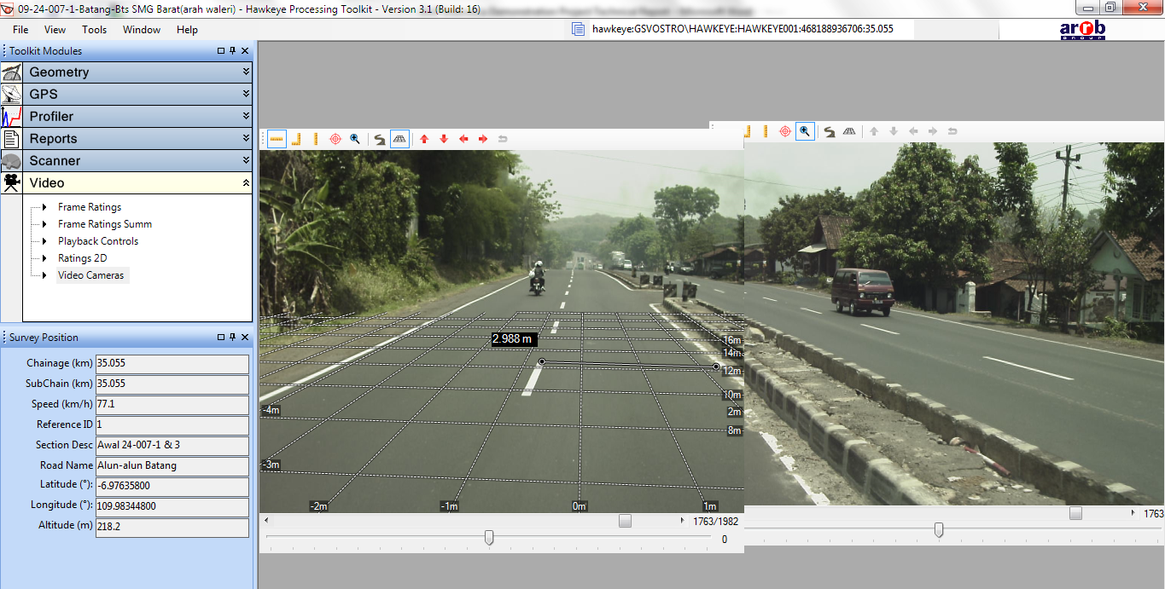

Table-2: Road attributes recorded by iRAP
Road attribute | Road user
 | Vehicle occupants | Motorcyclists | Pedestrians | Bicyclists
Bicycle facilities
Delineation
Intersection road volume level
Intersection type ª
Lane width
Median type ^{b}
Minor access point density
Number of lanes
Passing demand
Paved shoulder width
Pedestrian crossing facilities ^{c}
Quality of crossing ^{d}
Quality of curve ^{d}
Quality of intersection ^{d}
Radius of curvature
Pavement condition
Roadside design/obstacles ^{e}
Shoulder rumble strips
Side friction/roadside activities
Sidewalk provision
Speed ^{f}

ª Intersection types includes 3-leg, 4-leg, roundabout, grade separation, railway, median crossing, provision of turning lanes and signalisation.
^{b} Median type includes centerlines (no median), centerline rumble strips, two-way left-turn lanes, and various width of raised, depressed, or flush medians with and without barriers.
^{C} Pedestrian facilities include unsignalised and signalised crossings, median refuges and grade separation.
^{d} The quality of crossing, curve, and intersection includes consideration of pavement markings, advance signing, advisory speed limits, and sight distance.
^{e} Roadside design/obstacles includes non-frangible objects such as trees and poles, drains, embankments, cuts, cliffs and the distance of objects from the side of the road.
^{f} Speed is based on ‘operating’ speed.

Traffic volumes
Traffic volume data is used by the iRAP model in the generation of estimates of the number of deaths and serious injuries that could be prevented on the roads.

Data provided by DGH (Bina Teknik Directorate) shows that volumes vary between 5,684 vehicles per day (vpd) (on the inter-urban roads) and 295,966 vpd (on the urban roads), as shown in Figure 5 below. The length-weighted average volume along the road is 35,779 vehicles per day.

Figure 5: Annual Average Daily Traffic (AADT)
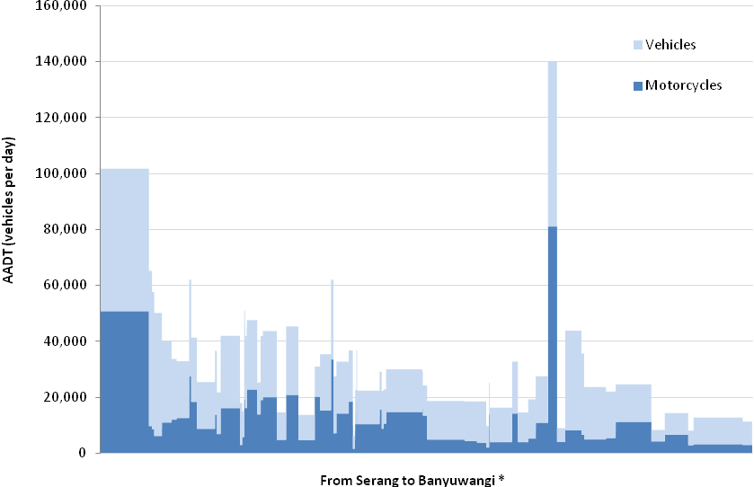
* The chainages shown are not continuous; sections of road not surveyed are exluded.
Source: Bina Teknik - Seksi Keselamatan Jalan (Road Safety Section).

The traffic composition varies according to whether the road is in an urban or rural area. In general:
- cars account for between 15% and 82% of traffic
- motorcycles account for between 10% and 80% of traffic
- goods vehicles account for between 0% and 49% of traffic
- other vehicles account for between 0% and 19% of traffic.

Combining the traffic volume dataset with the survey dataset proved to be a significant challenge because the location referencing systems used were different (that is, different road section names, different chainages, no GPS coordinates in the traffic volume set).

Bicyclist (and non-motorised vehicle) volumes
Bicyclist flows (which for the purposes of this project include non-motorised vehicles) are used by the iRAP model in the generation of estimates of the number of deaths and serious injuries that could be prevented on the roads. As Figures 6 and 7 show, there are locations which carry significant bicyclist volumes. Data provided by Bina Teknik shows that where bicyclist flows are greater than zero, they vary between 3 and 14,000 people per day.

Figure 6: Bicyclists and non-motorised vehicles on A. Yani – Sudirman - Kota
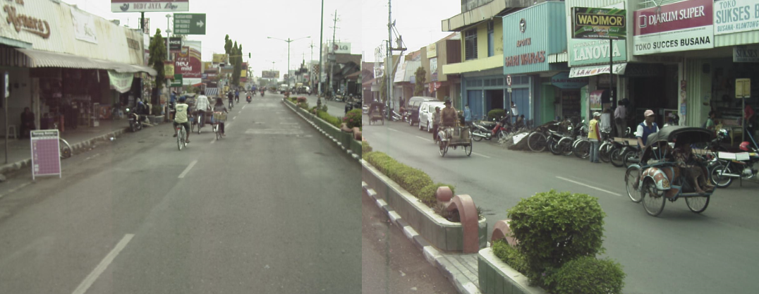

Figure 7: Bicyclist and non-motorised vehicle flows per day
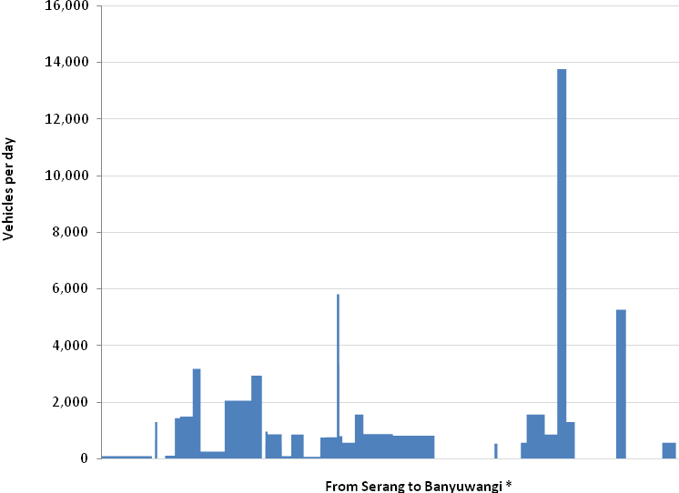
* The chainages shown are not continuous; sections of road not surveyed are exluded.
Source: Bina Teknik - Seksi Keselamatan Jalan (Road Safety Section).

The iRAP model uses pedestrian flows in four categories: none, low, medium and high. Table 3 shows how the recorded pedestrian flows were allocated to the iRAP categories.

Table-3: Pedestrian flow categories
Category | Flow range
None | 0
Low | 1 to 100
Medium | 101 to 500
High | 501 +

The data in Figure 7 was combined with observations of bicycle flows made by the coding team. The final bicycle flow was determined by using the larger of the measured flow and observed flow.

The challenges described in the previous section - in combining the traffic volume dataset with the survey dataset – also applied to the bicyclist and non motorized vehicle data set.

Pedestrian volumes
Pedestrian flows are used by the iRAP model in the generation of estimates of the number of deaths and serious injuries that could be prevented on the roads.

Data on pedestrian flows were recorded during the road coding. This data was recorded for flows along and across the road, and categorised into four groups: none, low, medium and high. It is possible to rely solely on this data for processing, though it is not recommended. This is because pedestrian flows can be transitory and a one-off visual inspection is unlikely to provide a strong basis for determining overall flows. Ideally, detailed survey data on pedestrian movements are used to complement on the iRAP rating data. When this is not available though, as is the case here, an alternate method, drawing on the following fields is used:
- area type
- sidewalk provision
- pedestrian crossing facility provision
- land use fields.

This approach was used for this project.

Speed
The level of risk of death or serious injury on a road is highly dependent on the speed at which traffic travels. iRAP policy is that risk assessments are made using the ‘operating speed’ on a road. Operating speed is defined as being the legislated speed limit or the measured 85th percentile speed.

There are a number of issues to consider in determining the operating speeds for the North Coast Corridor:
- The survey and coding showed that there is no evidence that there is a speed limit in place on the road.
- The World Health Organisation reports that Indonesia has a legislated speed limit in urban areas of 70km/h (WHO, 2009). However, as per point 1 above, there is no evidence that this is operationalised on the corridor.
- The 85th percentile speed at which the survey vehicle travelled along the corridor while collecting data was: 76km/h on rural roads and 72km/h on urban roads.
- The video images indicate that in numerous locations, the survey vehicle was passed by faster moving traffic, especially buses and motorcycles.
- A limited speed sampling exercise conducted as part of the demonstration project (at 3 sites only) showed that 85th percentile speeds were: 59km/h on urban sections and 52km/h on an inter-urban section. It is noted however, that the inter-urban location experiences very high traffic volumes (greater than 100,000 vehicles per day, which could result in slower traffic than normal). Figure 8 illustrates the results of the speed sampling.
- DGH and IRE have calculated ‘theoretical speeds’ based on the methodology in the Indonesia Design Manual. These are a function of geometry, cross section and volumes. However, the speeds estimated are typically much lower than the value of speeds observed by the survey vehicle and in the samples.
- Initial guidance provided by IndII’s road safety consultant suggested that general operating speeds could be: 60km/h on rural roads and 40km/h on urban roads. These relatively low figures were suggested because of high volumes and low road quality.

Taking into account the issues above, it was determined that the preliminary results should be calculated using the following speeds:
- Urban: 50km/h
- Rural: 60km/h

The speeds selected reflect an attempt to balance the issues discussed above. However, as shown later in this report, sensitivity tests with different speeds were also undertaken.

Figure 8: Speed sampling results (sample size ~100 vehicles)

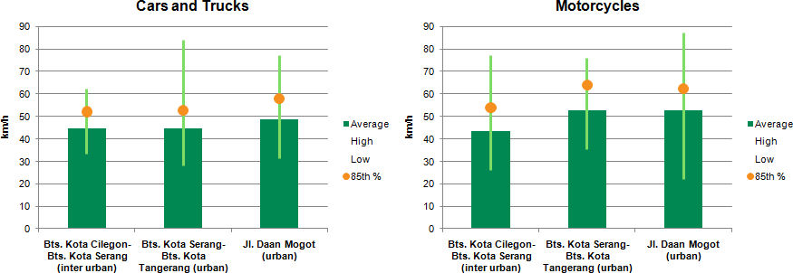

Number of deaths and serious injuries
As part of the iRAP model calibration, an estimate of the number of deaths and serious injuries that occur on the road, both in aggregate terms and by road user type, is required.

Estimated number of deaths
Estimating the number of deaths that occur on Jalan Lintas Pantura Jawa each year is very difficult. There is a number of different sources of incomplete data, and evidence of under reporting.

The number of deaths reported by the Road Safety Section of Bina Teknik is summarised in Table 4 below. The data reported is for varying sample periods, hence the inconsistent column headings in the Table. The table also includes an additional column to indicate the way in which this data was allocated to the four iRAP road user categories.

Table-4: Reported road deaths on Jalan Lintas Pantura Jawa

Road User | 2006-2009 | 2008 | 2008-2009 | 2008-2010 | iRAP Category
Becak |  | 3 |  |  | Motorcyclists
Bus |  |  | 4 |  | Car occupants
Cyclist |  | 8 | 1 |  | Bicyclists
Minibus |  |  | 4 |  | Car occupants
Motorcycle | 10 | 278 | 59 | 3 | Motorcyclists
n/a |  |  | 69 |  | Other
Others |  | 1 |  |  | Other
Pedestrian | 1 | 9 | 4 |  | Pedestrians
Vehicle occupants |  | 78 | 18 |  | Car occupants
Source: Bina Teknik - Seksi Keselamatan Jalan (Road Safety Section).
Based on this, an average of 460 deaths per year are recorded on Jalan Lintas Pantura Jawa. This implies a rate of 0.34 deaths per kilometre.

However, Crash Reduction Reports prepared by VicRoads as part of recent IndII projects indicate a higher number of deaths. The studies for East, Central and Western Java Provinces indicate that 585 fatal crashes were recorded by Police on 1,150km of Jalan Lintas Pantura Jawa (IndII, 2011). The report indicates that, at the crash reduction sites, an average of 1.19 deaths occurred in each fatal crash. This implies a death rate of 0.61 deaths per km for the 1,150km of roads.

The IndII report also highlight a number of issues about the quality of the data. This is echoed by the Asian Development Bank (ADB) and World Health Organisation (WHO) and anecdotal reports about under reporting:
- a report for the Asian Development Bank (ADB) estimated that the number of deaths in 2004 was 30,464, which is 3.5 times higher than the 8,762 deaths reported by police for that year (ADB-ASEAN, 2004)
- the World Health Organisation (WHO) estimated that 37,438 deaths occurred in 2007, which is 2.7 times higher than the reported 16,548 deaths in 2007 (WHO, 2009)
- advice provided by the Bina Teknik - Seksi Keselamatan Jalan (Road Safety Section) is that as many as 1,000 deaths could occur on the entire North Coast Corridor each year (1,300km), representing a death rate of 0.77 deaths per km, which is 2.2 times higher than their reported number (see Table 4).

For the purposes of this project, a death rate of 0.75 deaths per km was used.

Deaths by road user type
In order to allocate deaths and serious injuries to the network, the iRAP model requires an estimate of the distribution of deaths by road type. The proportion of deaths on the road by road user type was estimated following a review of data from two sources, as shown below in Table 5. The estimates used are based on the average of the data.

Table-5: Reported road deaths by iRAP road user category

Road User | Reported (from Table 5.1) | WHO, 2009 | Average
Vehicle occupants | 21% | 7% | 14%
Motorcyclists | 74% | 64% | 69%
Pedestrians | 3% | 16% | 9%
Bicyclists | 2% | 14% | 8%
Note: deaths categorised as ‘na’ and ‘others’ were not used in determining percentages.

Number of Deaths and Serious Injuries
The number of serious injuries on the road was estimated using the standard iRAP assumption that for each death 10 serious injuries occur. This is based on research by McMahon and Dahdah (2009). On this basis, if it is assumed that 1,000 deaths occur on the North Coast Road each year, then 10,000 serious injuries are estimated to occur. On this basis, it is estimated that for the 836km under assessment, there are 627 deaths and 6,270 serious injuries each year.

Economic cost of a death and serious injury
Safer Roads Investment Plans: The iRAP Methodology describes the iRAP methodology used to estimate the economic cost of a road death and a serious injury in for iRAP projects. This approach is applied globally by iRAP and is based on research undertaken by McMahon and Dahdah (2008). It is the approach preferred by the Global Road Safety Facility for iRAP projects. It is noted that this approach may result in estimates that differ from those undertaken in the past using a different methodology.

The key equations used are:
- the economic cost of a death is estimated to be: 70 x Gross Domestic Product (GDP) per capita (current price)
- the economic cost of a serious injury is estimated to be: 0.25 x economic cost of a death.

On this basis:
- the economic cost of a death in Indonesia is estimated to be 70 x Rp 30,783,361 =
Rp 2,154,835,270 (USD 252,293)
- the economic cost of a serious injury is estimated to be: 0.25 x Rp 2,154,835,270 = Rp 538,708,817 (USD 63,073).

Drawing on this data and the numbers provided in the previous section, it is estimated that deaths and serious injuries on the 836km of Jalan Lintas Pantura Jawa under assessment cost $553 million annually.

Countermeasure costs
The iRAP model requires the input of local construction and maintenance costs for the 70 countermeasures that are considered in the development of the Safer Roads Investment Plans. The costs are categorised by area type (urban, semi-urban and rural) and upper and lower costs (low, medium and high).

The countermeasure costs used in the preliminary analysis were largely provided by DGH – National Road Implementation Section for sector 3 (Balai Besar Pelaksanaan Jalan Nasional III -BPPJN III). However, some adjustments were made to the costs. These mostly involved increasing the cost for roadside hazard removal, duplication, footpaths and intersections, which appeared low in the original data. The full data set is shown Annexe 3.

Discount rate
To calculate Net Present Costs and Benefits, a discount rate of 4% was used.

- Detailed Condition Report
This chapter gives a summary of the condition of the surveyed roads for each of the road attributes included in the iRAP models. More detailed reports on the road condition, for every sub-section of the corridor, are available in the iRAP online software (www.iraptools.net).

Some of the indicators which help describe the safety performance of the infrastructure are:
- 58% of motorized vehicle travel occurs on roads that have no form of median separation (relating to head on risk)
- 65% of motorized vehicle travel occurs on roads that have no shoulders and hazardous roadsides (relating to run-off road risk)
- 99% of motorcycle travel occurs on roads with no specific motorcycle facilities
- 41% of motorized vehicle travel occurs on roads that have high pedestrian traffic and no footpaths or pedestrian crossings
- 44% of motorized vehicle travel occurs on roads that have high bicycle flows and no bicycle facilities.

Figure 9 summarises the road attributes for the 836km of road surveyed.

Figure 9: Road conditions for Jalan Lintas Pantura Jawa

Vehicles per day Length (km) %  5001 - 10000 41.4 km 5  10001 - 15000 151.2 km 18  15001 - 20000 119.3 km 14  20001 - 40000 309.3 km 37  40001 - 60000 130.7 km 16  60001 - 80000 9.5 km 1  > 100000 74.6 km 9  Motorcycle flow (% of traffic) Length (km) %  11% - 20% 83.4km 10  21% - 40% 366.3km 44  41% - 60% 379.3km 45  61% - 80% 7km 1  Bicycle flow Length (km) %  Not recorded / none 100.1km 12  Low 274.5km 33  Medium 96.3km 12  High 365.1km 44  Pedestrian flow across the road Length (km) %  Not recorded / none 62.9km 8  Low 279.1km 33  Medium 459.8km 55  High 34.2km 4  Pedestrian flow along the road Length (km) %  Low 79.8km 10  Medium 332.2km 40  High 424km 51  Area type Length (km) %  Rural 101.3km 12  Semi-urban 429.6km 51  Urban 305.1km 36  Number of lanes for use by through traffic Length (km) %  One 532.7km 64  Two 293km 35  Three 8.4km 1  Four or more 1.9km 0  One way / two way flow Length (km) %  One way traffic 18km 2  Two way traffic 818km 98  Speed Length (km) %  50km/h 305.1km 36  70km/h 530.9km 64  Motorcycle facilities - speed Length (km) %  50km/h 305.1km 36  70km/h 530.9km 64  Lane width for lanes serving through traffic Length (km) %  Wide (> 3.25m) 338.5km 40  Medium (2.75m <= to <= 3.25m) 483.9km 58  Narrow (0.0m to < 2.75m) 13.6km 2  Paved shoulder width Length (km) %  Wide (>= 2.4m) 4.2km 0  Medium (1.0m < to < 2.4m) 35.8km 4  Narrow (0.0m < to <= 1.0m) 184.4km 22  None 611.6km 73  Unpaved shoulder width Length (km) %  Wide (>= 2.4m) 147.9km 18  Medium (1.0m < to < 2.4m) 418.9km 50  Narrow (0.0m < to <= 1.0m) 129.7km 16  None 139.5km 17  Curvature Length (km) %  Straight or gently curving 735.1km 88  Moderate 86.3km 10  Sharp 12.7km 2  Very sharp 1.9km 0  Quality of curve Length (km) %  Adequate 755.3km 90  Poor 80.7km 10  Overtaking demand Length (km) %  None 304.8km 36  Low 61.3km 7  Medium 469.9km 56  Delineation Length (km) %  Adequate 394.2km 47  Poor 441.8km 53  Vertical alignment variation Length (km) %  Flat 808.2km 97  Undulating / rolling 25.3km 3  Significant crests and dips 2.5km 0  Sidewalk provision - left Length (km) %  Physical barrier 2.2km 0  Non-physical separation > 3m 8.2km 1  Non-physical separation > 1.0m <= 3.0m 68.5km 8  Adjacent to traffic 128.1km 15  None 629km 75  Sidewalk provision - right Length (km) %  Physical barrier 2.8km 0  Non-physical separation > 3.0m 6.6km 1  Non-physical separation > 1.0m <= 3.0m 64.2km 8  Adjacent to traffic 133.5km 16  None 628.7km 75  Not recorded 0.2km 0  Median Type Length (km) %  High quality barrier 3.8km 0  Physical median width > 20.0m 1.9km 0  Physical median width 10.0m - 20.0m 2.9km 0  Physical median width 5.0m - 10.0m 115.6km 14  Physical median width 1.0m - 5.0m 163.2km 20  Central hatching 3.1km 0  Centre line only 531.2km 64  One way road 14.3km 2  Major upgrade cost Length (km) %  Low 178.8km 21  Medium 276.1km 33  High 381.1km 46  Motorcycle facilities - median Length (km) %  Not applicable (e.g. one way road) 836km 100  Roadworks Length (km) %  No roadworks 787.4km 94  Roadworks in progress 48.6km 6 |  | Road condition Length (km) %  Good 209.1km 25  Medium 495.8km 59  Poor 131.1km 16  Land use - left Length (km) %  Undeveloped areas 222.9km 27  Development other than residential or commercial 30.5km 4  Residential 253.4km 30  Commercial 329.2km 39  Land use - right Length (km) %  Undeveloped areas 220.2km 26  Development other than residential or commercial 48.5km 6  Residential 236.3km 28  Commercial 331km 40  Side friction Length (km) %  Low 366.9km 44  Medium 391.3km 47  High 77.8km 9  Shoulder rumble strips Length (km) %  No 832.8km 100  Yes 3.2km 0  Pedestrian crossing facilities Sites  Signalised with refuge 19 sites  Signalised without refuge 52 sites  Unsignalised marked crossing with refuge 50 sites  Unsignalised marked crossing without refuge 224 sites  Refuge only 3 sites  No facility 8012 sites  Pedestrian crossing quality Sites  Adequate 69 sites  Poor 279 sites  Not applicable 8012 sites  Bicycle facilities Length (km) %  Segregated bicycle path with barrier 2.2km 0  Segregated bicycle path 1.7km 0  Dedicated bicycle lane on road 3.2km 0  None 828.9km 99  Motorcycle facilities Length (km) %  Segregated one-way motorcycle path with barrier 3km 0  Segregated one-way motorcycle path without barrier 15.4km 2  Segregated two-way motorcycle path with barrier 0.1km 0  Segregated two-way motorcycle path without barrier 0.2km 0  None 817.3km 98  Minor access point density Length (km) %  Low 698km 83  Not applicable 138km 17  Roadside severity - left Length (km) %  Cut 4km 0  Deep drainage ditches 63.8km 8  Steep fill embankment slopes 4.3km 1  Distance to object 0.0m - 5.0m 697.7km 83  Distance to object 5.0m - 10.0m 15.6km 2  Distance to object > 10.0m 10.6km 1  Motorcyclist friendly barrier 0.2km 0  Cliff 0.3km 0  Safety barrier concrete (CEN) 39.5km 5  Roadside severity - right Length (km) %  Safety barrier 40.3km 5  Cut 1km 0  Deep drainage ditches 3.1km 0  Steep fill embankment slopes 55.8km 7  Distance to object 0.0m - 5.0m 706.6km 85  Distance to object 5.0m - 10.0m 12km 1  Distance to object > 10.0m 16km 2  Motorcyclist friendly barrier 0.1km 0  Cliff 1.1km 0  Bicycle facilities - roadside severity Length (km) %  Safety barrier 1km 0  Distance to object 0.0m - 5.0m 5.3km 1  Motorcyclist friendly barrier 0.7km 0  Not recorded 829km 99  Motorcycle facilities - roadside severity Length (km) %  Safety barrier 2.8km 0  Distance to object 0.0m - 5.0m 15.7km 2  Motorcyclist friendly barrier 0.2km 0  Not recorded 817.3km 98  Major intersection type Sites  Merge lane 4 sites  Roundabout 11 sites  3-leg (unsignalised) with cross-traffic turn lane 2 sites  3-leg (unsignalised) without cross-traffic turn lane 88 sites  3-leg (signalised) with cross-traffic turn lane 1 sites  3-leg (signalised) without cross-traffic turn lane 58 sites  4-leg (unsignalised) without cross-traffic turn lane 16 sites  4-leg (signalised) with cross-traffic turn lane 1 sites  4-leg (signalised) without cross-traffic turn lane 24 sites  Non-major junctions or driveways (rural roads only) 29 sites  None 7978 sites  Railway crossing - passive (signs only) 3 sites  Railway crossing - active (flashing lights / boom gates) 12 sites  Median crossing point - poor condition 79 sites  Median crossing point - good condition 54 sites  Intersection quality Sites  Good 152 sites  Poor 230 sites  Not applicable 7978 sites

- Star Ratings
Following the inspections and coding of the road infrastructure attributes, a Road Protection Score (RPS) was calculated for each 100 metre section using the iRAP’s online software (which is made freely available to project partners). A separate RPS is calculated for vehicle occupants, motorcyclists, pedestrians and bicyclists. The RPS forms the basis for generating the Star Ratings (and, in turn, Safer Roads Investment Plans). The approach taken was consistent with the methodology described in Safer Roads Investment Plans: The iRAP Methodology which is available at:
http://irap.org/media/9573/irap504.04_star_rating_roads_for_safety.pdf.

Road Protection Scores
The RPS is based on risk factors that relate each road infrastructure attribute coded with the relative likelihood of crashes and their severity. An example of research underpinning one set of risk factors – horizontal alignment - is shown below in Figure 10. It plots crash rates versus horizontal curvature. It shows that the relative risk between a road segment with a very sharp curve (radius less than 100 metres) and one with a very mild, or no curve, is approximately 5.5. At the radius range of 100-200 metres, where the greatest number of crashes was observed, the risk ratio is 3.5. This finding is supported by other published literature also.

Notably, the RPS is largely independent of traffic volumes and actual crash rates on the road being assessed. These factors are taken into account later, in the Safer Roads Investment Plan stage.

Figure 10: Casualty crash rates and curve radius

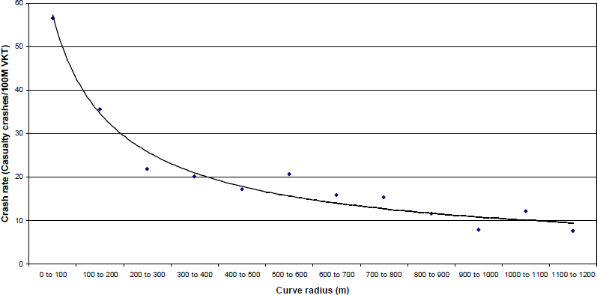

Figure 11 shows the underlying level of risk (RPS) for motorcyclists for each 100 metre section of the Batas – Tegal section of Jalan Lintas Pantura Jawa (the higher the score, the greater the risk). It illustrates the variation in risk as the motorcyclist travels along the road (eastbound direction). The spikes in risk tend to be intersections, where the presence of cross-traffic greatly increases the likelihood of severe injury. Complete RPS plots are available in the iRAP online software at www.iraptools.net.
Figure 11: Road Protection Scores for motorcyclists on the Batas – Tegal section
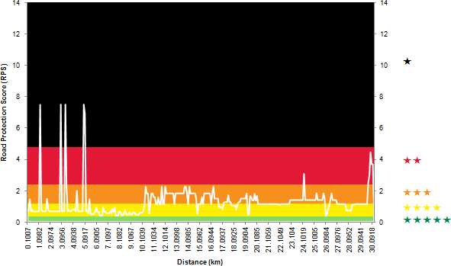

Overall Star Ratings Results
The overall Star Ratings for the roads assessed is shown below in Table 6. In summary for Jalan Lintas Pantura Jawa, for:
- vehicle occupants, 17% is 1 or 2-star
- motorcyclists, 43% is 1 or 2-star
- pedestrians, 72% is 2-star
- bicyclists, 66% is 2-star.
Table-6: Overall Star Ratings
Road user type | Length (km) | Not  rated *
Vehicle occupants | 836 | 0% | 2% | 15% | 34% | 36% | 14%
Motorcyclists | 836 | 0% | 11% | 32% | 26% | 29% | 2%
Pedestrians | 836 | 0% | 0% | 72% | 28% | 0% | 0%
Bicyclists | 836 | 12% | 0% | 66% | 14% | 9% | 0%
* Roads that have no bicycle flows are not star rated.

Table 7 summarizes the Star Ratings by distance traveled by motorized vehicles. It shows that:
- 48% of motorized travel occurs on roads rated 1- and 2-stars for vehicle occupants
- 43% of motorcycle travel occurs on roads rated 4- and 5-stars for motorcyclists
- 69% of motorized travel occurs on roads rated 1- and 2-stars for pedestrians
- 69% of motorized travel occurs on roads rated 1- and 2-stars for bicyclists.
Table-7: Total travel by Star Rating
Road user type | Total kilometers traveled per year (million)
Vehicle occupants | 10,052 * | 1% | 15% | 34% | 36% | 14%
Motorcyclists | 4,098 ** | 8% | 26% | 23% | 39% | 4%
Pedestrians | 10,052 * | 0% | 69% | 31% | 0% | 0%
Bicyclists | 10,052 * | 0% | 67% | 13% | 13% | 0%

* All motorized vehicles
** Motorcycles only

Star Rating Maps
Figures 12 to 15 illustrate the Star Ratings in map form for each of the vehicle occupants, motorcyclists, pedestrians and bicyclists.
Figure 12: Star Ratings for vehicle occupants
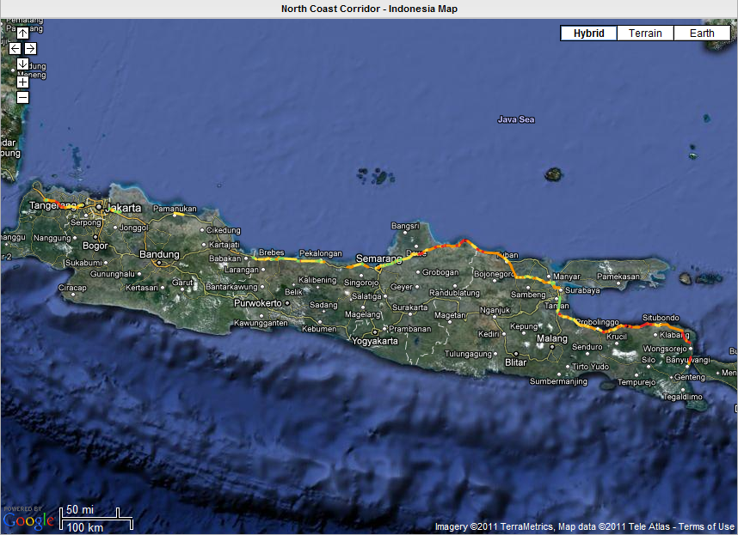

Figure 13: Star Ratings for motorcyclists
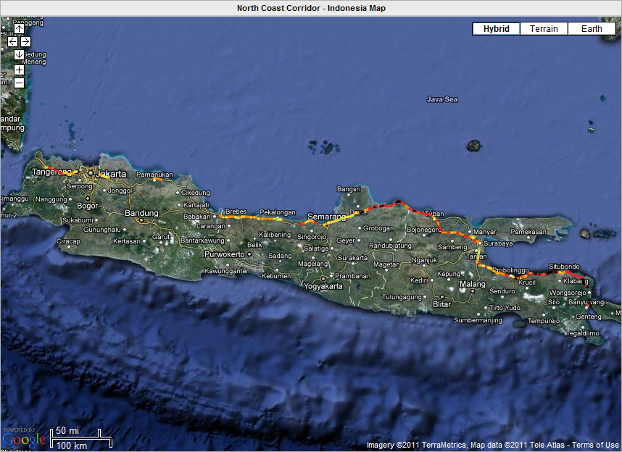
Figure 14: Star Ratings for pedestrians
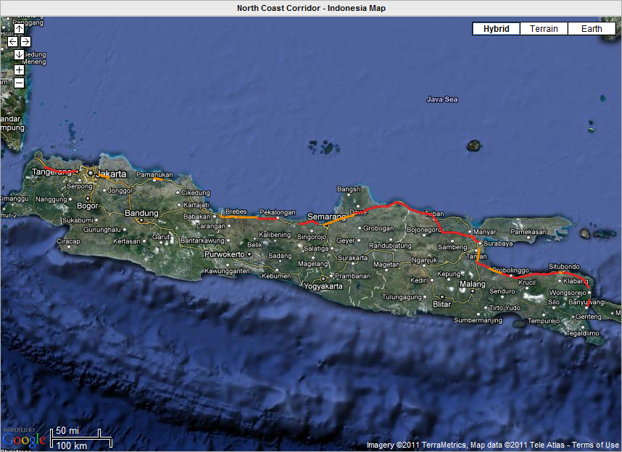

Figure 15: Star Ratings for bicyclists
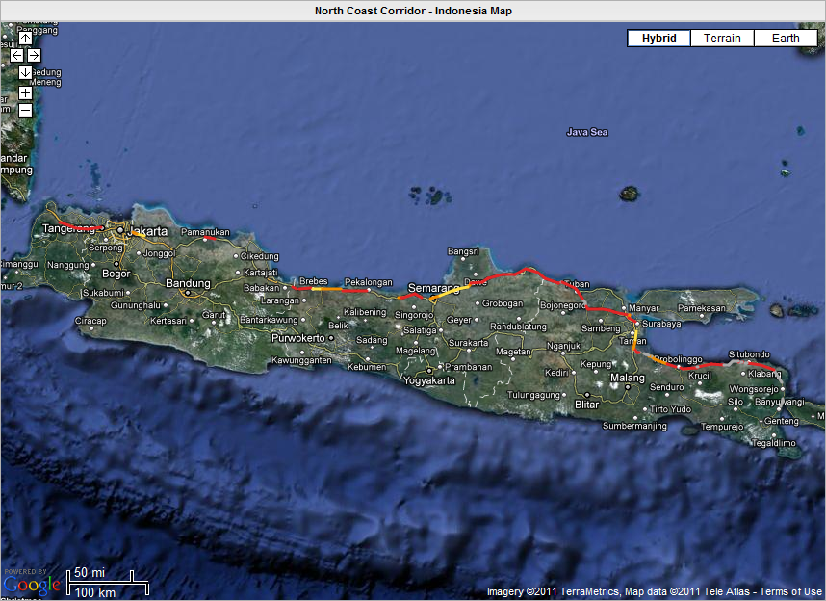

Examples of Star Ratings
The following images show examples of sections of roads, their Star Ratings and the road attributes that influenced the Star Rating. In the figures:
- Green coloured attributes are associated with a reduced level of risk
- Yellow coloured attributes are associated with a intermediate level of risk
- Red coloured attributes are associated with an increased level of risk.

The images help to illustrate the fact that the level of risk associated with a road’s infrastructure, and hence its Star Rating, is a function of numerous attributes, including travel speeds.

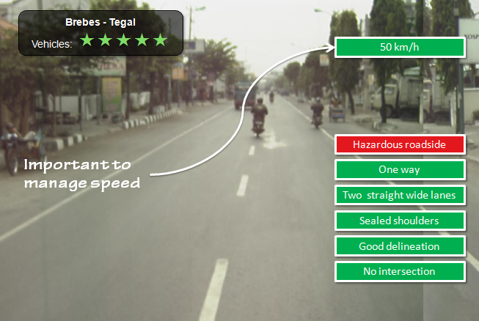

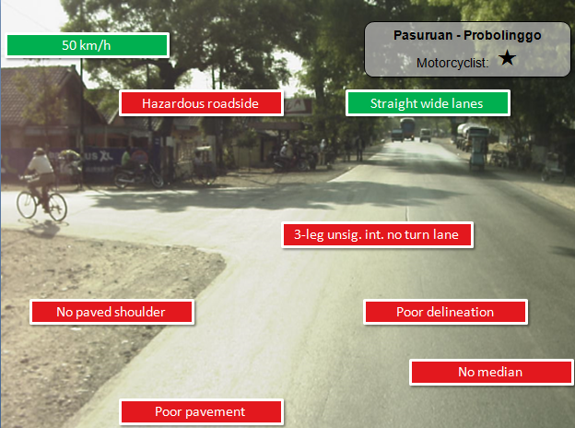
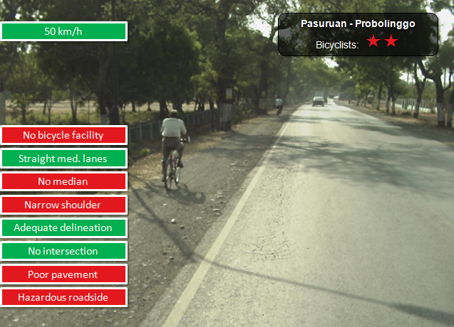

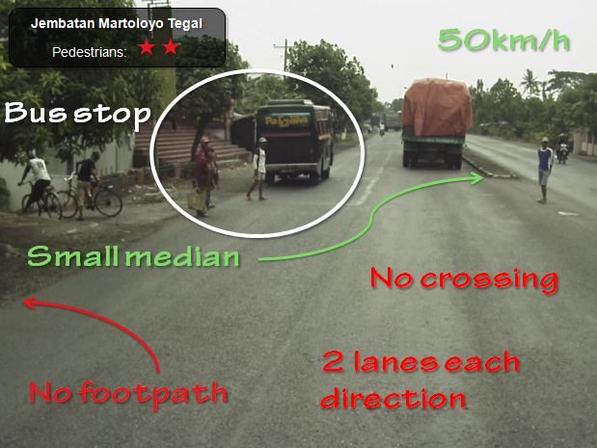

- Recommended Infrastructure Investment
The purpose of a Safer Roads Investment Plan is to provide an appreciation of the types of countermeasures that could affordably and economically reduce risk – and therefore prevent deaths and serious injuries. To do this, iRAP considers the suitability of various countermeasures from a list of 70 countermeasures, ranging from low-cost road markings and pedestrian refuges to higher-cost intersection upgrades and full highway duplication (more information on the countermeasures in the iRAP list is available in the Road Safety Toolkit: http://toolkit.irap.org).

The process used to generate Safer Roads Investment Plans in the Indonesia Demonstration Project was consistent with the approach described in the paper titled Safer Roads Investment Plans: The iRAP Methodology (available for download at: www.irap.org/library.aspx.

In general terms three steps were taken, as summarised below.

- Estimating the number of deaths and serious injuries on road sections

To enable economic evaluation of various countermeasure options, an estimate of the number of deaths and serious injuries under existing conditions on each 100 metre section of road was made. As discussed in earlier, it is estimated that 621 people were killed in crashes on the section of Jalan Lintas Pantura Jawa being assessed.

Since the number of deaths was available only in aggregate form (that is, for the entire length of each road), the deaths needed to be distributed among the 100 metre sections of road. The number distributed to each section was a function of the product of each section’s Road Protection Score (RPS) and exposure (in the case of vehicle occupants, exposure is measured as the annual average daily traffic). Hence, it is feasible that a road with a 1-star rating (indicating high risk) can still experience very few deaths if its traffic volume is low, and the reverse is also true.

An estimate of the number of serious injuries on each section was then made by assuming that for each death, 10 serious injuries occur. This approach is based on research by McMahon and Dahdah (2008).

- Selecting countermeasures

For each 100 metre section of road, a series of countermeasures that feasibly could be implemented were identified. This was achieved by considering each countermeasure’s ability to reduce risk (as measured by the RPS) and ‘application’ and ‘hierarchy’ rules. For example, a section of road that has a poor pedestrian RPS and high pedestrian activity was likely to benefit from the installation of a pedestrian refuge, pedestrian crossing or signalised pedestrian crossing. Similarly, a section of road with poor delineation and a high car occupant RPS was likely to benefit from better delineation.

‘Application’ rules were used to help ensure that the countermeasures identified align with reasonable engineering practice. For example:
- grade-separated pedestrian crossings should be at least one kilometre apart. Hence, a grade separated crossing was not be considered feasible if one has already been identified for the previous 100 metre section
- new signalised pedestrian crossings (non-intersection facilities) should be at least 600 metres apart
- additional lanes (such as overtaking lanes or 2+1 cross section) should be required for a minimum length of one kilometre.

‘Hierarchy’ rules were used to ensure that more comprehensive countermeasures took precedent over less effective countermeasures. For example:
- if a grade separated pedestrian facility was feasible then it took precedent over other pedestrian measures (such as a pedestrian refuge or signalised crossing)
- if a horizontal realignment was feasible then redundant countermeasures were not considered (for example, curve delineation and shoulder widening)
- if a segregated motorcycle lane was feasible then other motorcycle lanes (such as an on-road motorcycle lane) were removed from the plan.

- Economic analysis

Each countermeasure option identified was then subject to a benefit cost ratio (BCR) analysis. Countermeasures that failed to achieve a BCR of at least 1 were excluded from the analysis. However, higher BCR thresholds were also used to develop less expensive plans.

The benefit of a countermeasure was determined by calculating the net present value of deaths and serious injuries that would be avoided over twenty years if the countermeasure were installed (a discount rate of 4% was used). The reduction in deaths and serious injuries was determined by replacing the RPS used in the original estimate (made in the process of distributing deaths among 100 metre sections of road) with a new, lower RPS.

The economic cost of a death or serious injury is described in Chapter 3.

Rp 89 billion (US $10 million) Safer Roads Investment Plan
Using inspection and supporting data with the iRAP methodology, an investment plan for each sub-section of the corridor was produced. For the purposes of this project, two sets of plans were produced: the first for a budget of Rp 89 billion (US $10 million) and the second for a budget of Rp 2.9 trillion (US $350 million), which includes all countermeasures with a benefit cost ratio of 1 or greater.

The first plan is summarised in Table 8. In this plan, an investment of Rp 89 billion would prevent 33,950 deaths and serious injuries over 20 years, representing a 25% reduction in road trauma. The investment would save Rp 14 trillion (US $1.6 billion) in crash costs avoided. Full details for each of the plans are available in the iRAP online software (www.iraptools.net).

Table-8: Overview of the Rp 89 bn (US $10 m) investment plan for Jalan Lintas Pantura Jawa
 | Rupiah | USD
Investment | 89 billion | 10.4 million
Economic benefit (20 years) | 14,083 billion | 1,648 million
Benefit cost ratio | 158
Deaths (per year)
Before countermeasures | 627
After countermeasures | 485
Prevented | 142
Deaths and serious injuries (20 years)
Before countermeasures | 137,940
After countermeasures | 106,670
Prevented | 31,270
Reduction | 23%
Cost per death and serious injury prevented | 2.8 million | 330
Note: USD 1 = IDR 8,541 (18 May 2011).

The countermeasures that are economically feasible in the Rp 89 billion (US $10 million) plan are summarised in Table 9.
Table-9: Recommended countermeasures in the Rp 89 bn (US $10 m) investment plan for Jalan Lintas Pantura Jawa (costs and benefits over 20 years)
Countermeasure Type | Length / Sites | KSI Saved | Economic Benefit  (Rp m) | Cost  (Rp m) | Cost per KSI saved (Rp ‘000) | BCR
Roadside Safety - Hazard Removal | 410 km | 15,070 | 6,789,640 | 30,870 | 2,048 | 220
Delineation | 320 km | 5,430 | 2,445,560 | 11,050 | 667 | 221
Shoulder widening | 20 km | 3,120 | 1,406,630 | 17,880 | 5,725 | 79
Motorcycle Lanes | 10 km | 2,380 | 1,073,790 | 8,150 | 3,420 | 132
Road Surface Upgrade | 20 km | 2,070 | 930,450 | 7,520 | 2,166 | 124
Bicycle Facilities | 130 km | 910 | 408,050 | 3,980 | 4,392 | 103
Intersection - signalise | 6 sites | 790 | 355,400 | 2,480 | 3,139 | 143
Intersection - delineation | 20 sites | 550 | 247,220 | 1,780 | 1,064 | 139
Roadside Safety - Barriers | 3 km | 340 | 152,360 | 1,910 | 5,656 | 80
Lane widening | 1 km | 180 | 81,390 | 1,210 | 3,998 | 67
Pedestrian Crossing | 20 km | 140 | 61,460 | 960 | 4,169 | 64
Central Hatching | 10 km | 140 | 60,970 | 550 | 2,399 | 112
Rumble strip / flexi-post | 5 sites | 90 | 42,460 | 400 | 2,511 | 107
Regulate roadside commercial activity | 3 km | 40 | 17,060 | 210 | 3,338 | 80
Additional lane | 1 km | 30 | 11,320 | 130 | 5,015 | 90
Total |  | 31,270 | 14,083,750 | 89,070 | 2,848 | 158
Notes:
- KSI = killed and serious injuries
- Numbers might not add due to rounding
- Countermeasures that span across both northbound and southbound carriageways (such as grade separated intersections and pedestrian overpasses) are reported as 2 sites in this table, with costs and benefits spread between the two.
Note: USD 1 = IDR 8,541 (18 May 2011).

Figure 16 illustrates where the largest gains could be made on Jalan Lintas Pantura Jawa with the Rp 89 billion (US $10 million) investment plan. Black sections of road indicate the more than 15 deaths and serious injuries per kilometre over 20 years could be prevented. At the other end of the spectrum, green sections indicate that no deaths or serious injuries would be prevented (that is, with a limited budget, investments on those sections is not a priority).

Figure 16: Deaths and serious injuries prevented map (Rp 89 billion / US $10 million plan)

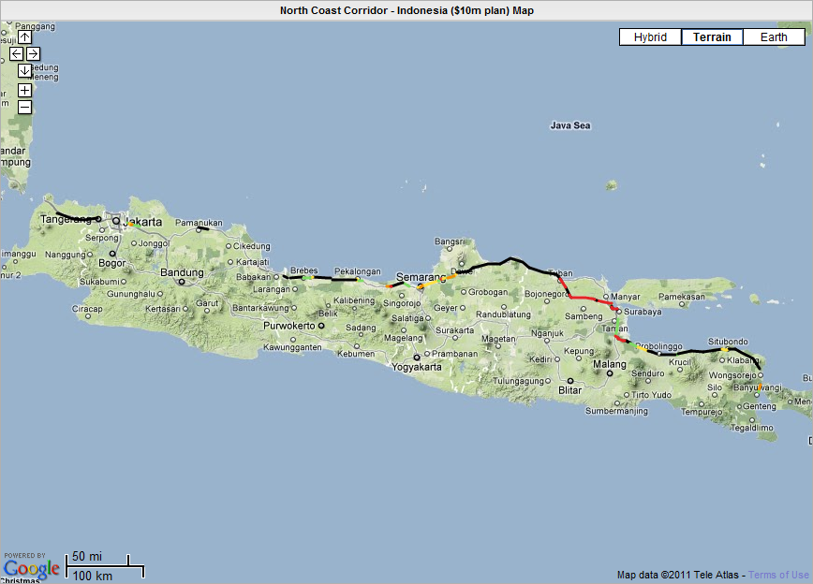

Rp 2.9 trillion (US $350 million) Safer Roads Investment Plan
The second plan, which includes all countermeasures that generate a benefit cost ratio of 1 or greater, is summarised in Table 10. In this plan, an investment of Rp 2.9 trillion (USD $350 million) would prevent 68,890 deaths and serious injuries over 20 years, representing a 50% reduction in road trauma. The investment would save Rp 31 trillion (USD $3.6 billion) in crash costs avoided. Full details for each of the plans are available in the iRAP online software (www.iraptools.net).
Table-10: Overview of the Rp 2.9 trillion (US $350 million) investment plan for Jalan Lintas Pantura Jawa
 | Rupiah | USD
Investment | 2,978 trillion | 348 million
Economic benefit (20 years) | 31,030 trillion | 3,631 million
Benefit cost ratio | 10
Deaths (per year)
Before countermeasures | 627
After countermeasures | 314
Prevented | 313
Deaths and serious injuries (20 years)
Before countermeasures | 137,940
After countermeasures | 69,050
Prevented | 68,890
Reduction | 50%
Cost per death and serious injury prevented | 43 million | 5,100
Note: USD 1 = IDR 8,541 (18 May 2011).

The countermeasures that are economically feasible in the Rp 2.9 trillion (US $350 million) investment plan are summarised in Table 11.

Table-11: Recommended countermeasures in the Rp 2.9 trillion (US $350 million) investment plan (costs and benefits over 20 years)
Countermeasure Type | Length / Sites | KSI Saved | Economic Benefit  (Rp m) | Cost  (Rp m) | Cost per KSI saved (Rp ‘000) | BCR
Roadside Safety - Hazard Removal | 880 km | 25,290 | 11,391,770 | 710,770 | 28,102 | 16
Shoulder widening | 300 km | 8,020 | 3,613,840 | 211,530 | 26,364 | 17
Delineation | 380 km | 5,420 | 2,439,410 | 14,100 | 853 | 173
Motorcycle Lanes | 150 km | 5,190 | 2,338,440 | 69,170 | 13,316 | 34
Bicycle Facilities | 360 km | 4,290 | 1,932,670 | 161,550 | 37,649 | 12
Road Surface Upgrade | 110 km | 4,250 | 1,916,060 | 74,270 | 10,392 | 26
Duplication | 50 km | 3,600 | 1,619,210 | 587,480 | 163,417 | 3
Pedestrian Crossing | 2940 sites | 2,970 | 1,338,550 | 320,340 | 95,422 | 4
Intersection - grade separation | 8 sites | 2,310 | 1,041,450 | 358,720 | 155,140 | 3
Roadside Safety - Barriers | 50 km | 1,770 | 795,790 | 43,560 | 24,653 | 18
Lane widening | 70 km | 1,490 | 669,900 | 61,500 | 24,611 | 11
Pedestrian Footpath | 180 km | 980 | 441,770 | 179,410 | 182,917 | 2
Intersection - signalise | 80 sites | 910 | 411,690 | 35,280 | 38,601 | 12
Additional lane | 40 km | 740 | 332,320 | 72,640 | 98,453 | 5
Intersection - delineation | 140 sites | 540 | 241,620 | 16,980 | 10,377 | 14
Intersection - right turn lanes (signalised) | 60 sites | 310 | 140,000 | 29,820 | 57,100 | 5
Central Hatching | 40 km | 200 | 91,490 | 1,350 | 3,966 | 68
Regulate roadside commercial activity | 40 km | 180 | 82,420 | 3,600 | 11,715 | 23
Parking improvements | 20 km | 120 | 53,840 | 11,550 | 57,536 | 5
Rumble strip / flexi-post | 10 km | 110 | 49,240 | 690 | 3,768 | 71
Railway Crossing | 3 sites | 90 | 40,100 | 2,730 | 30,698 | 15
Intersection - right turn lanes (unsignalised) | 50 sites | 60 | 26,010 | 10,080 | 103,864 | 3
Median Barrier | 1 km | 50 | 22,470 | 1,100 | 13,131 | 20
Total |  | 68,890 | 31,030,070 | 2,978,230 | 43,229 | 10
Notes:
- KSI = killed and serious injuries
- Numbers might not add due to rounding
- Countermeasures that span across both northbound and southbound carriageways (such as grade separated intersections and pedestrian overpasses) are reported as 2 sites in this table, with costs and benefits spread between the two.
Note: USD 1 = IDR 8,541 (18 May 2011).

Figure 17 illustrates where the largest gains could be made on Jalan Lintas Pantura Jawa with the Rp 2.9 trillion (US $350 million) investment plan. Black sections of road indicate the more than 15 deaths and serious injuries per kilometre over 20 years could be prevented. The maps shows that there are investments that would generate large savings available along the entire length of Jalan Lintas Pantura Jawa.

Figure 17: Deaths and serious injuries prevented map (Rp 2.9 trillion / $350 million plan)
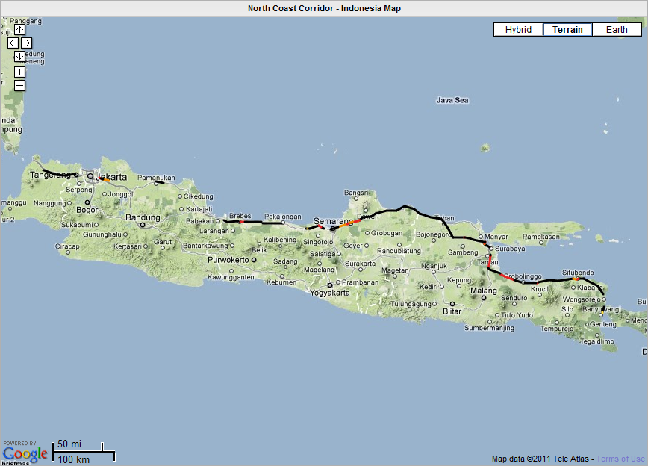

- Crash Reduction Investigations and iRAP
As part of the IndII Crash Reduction Program, a series of Crash Reduction Investigations (CRI) were undertaken by the Road Safety Engineering Unit and Seksi Keselamatan Jalan. CRI were completed for 31 locations sections of Jalan Lintas Pantura Jawa in East, Central and Western Java. The locations range from single intersections to lengths of about 20km, and were selected based on their reported crash history.

A comparison between the CRI and iRAP results has been made. This helps to illustrate the relative strengths of the approaches and how they fit together. The comparison includes general comments about the approaches and a more detailed comparison of the recommendations made for the section of Pantura between 3km and 23km north of Tuban.

Purpose of the different approaches
In making a comparison, it is important to have an appreciation of the different purposes of an iRAP assessment and a CRI:
- iRAP is designed to provide a network-level assessment of infrastructure risk for vehicle occupants, motorcyclists, pedestrians and bicyclists, and an economic assessment of countermeasure options.
- CRI are designed to provide detailed design recommendations about how short sections of road can be improved.

Level of risk on the section of Jalan Lintas Pantura Jawa between 3km and 23km north of Tuban
The East Java CRI report identifies the 20km section of Jalan Lintas Pantura Jawa located north of Tuban as being high risk based on reported crash data. In 2008, 30 deaths and 33 serious injuries were reported. The deaths involved motorcyclists, vehicle occupants and pedestrians.

The iRAP assessment identifies this section as high risk for vulnerable road users, as shown in the Table 12 below.

Table-12: Percentage of road rated 1- or 2-stars (out of a possible 5-stars)

Road user type | % 1- or 2-stars
Vehicle occupants | 5%
Motorcyclists | 85%
Pedestrians | 62%
Bicyclists | 100%

Similarities and differences between recommendations
The CRI reports for Jalan Lintas Pantura Jawa in East, Central and West Java identify the following key deficiencies:
- a lack of sealed shoulders throughout the length of highway
- provision of or maintenance of edgelines
- pelineation of hazards (i.e. bridge endwalls)
- road delineation, particularly at curves
- appropriate signage
- roadside hazards (removal and/or shielding)
- provision of appropriate signage
- lighting.

These deficiencies were also identified as key issues in the iRAP assessment. For example, iRAP found that 73% of the 836km of Jalan Lintas Pantura Jawa that was assessed has no sealed shoulders and 53% has poor delineation. The exception is lighting, which is not assessed by iRAP.

Table 13 (and the sketch in Figure 18) compares the recommendations made in each of the approaches for sections of Jalan Lintas Pantura Jawa located between 3km and 23km north of Tuban (the lengths/sites for the CRI were estimated from the report). The key differences between the two assessments are:
- The CRI recommendations provide a high level of detail, including exact quantities and detailed design drawings, whereas the iRAP recommendations are available to the nearest 100 metre.
- The range of road attributes assessed by iRAP – and recommendations made – is broader than the CRI range. iRAP recommendations include motorcycle lanes, bicycle lanes, footpaths and intersection improvements.
- The CRI recommendations are grouped into one of four categories according with their scale of work and the timing of the implementation of identified treatments. The cost and benefits of iRAP recommendations are quantified with a cost estimate, estimates of the reduction in deaths and serious injuries and benefit cost ratios.

Table-13: Summary of recommendations made in the CRI and by iRAP

Countermeasure | CRI |  | iRAP
 | Length/  sites | Cost | Length/  sites | Cost | KSI prevented | Av. BCR *
Bicycle facilities (km) |  |  | 0.9 | $2,024 | 1 | 37
Curve delineation (km) | 0.4 | Category A
Delineation (km) | 3.3 | Category A | 5.8 | $29,918 | 42 | 90
Duplication (km) |  |  | 1.1 | $1,483,956 | 42 | 1
Footpath (km) |  |  | 10.0 | $1,149,192 | 38 | 2
Guideposts (km) | 20.0 | Category A
Intersection delineation (sites) |  |  | 4.0 | $53,490 | 4 | 4
Intersection turn lanes (unsignalised) |  |  | 3.0 | $144,378 | 4 | 1
Motorcycle lanes (km) |  |  | 12.0 | $497,907 | 73 | 8
Reduce speed limits (km) | 3.0 | Category A
Refuge island (km) |  |  | 7.1 | $353,559 | 26 | 4
Roadside hazard removal (km) |  |  | 19.4 | $755,668 | 492 | 35
Rumble strips (km) | 3.6 | Category A | 2.1 | $15,865 | 8 | 27
Safety barriers (km) | 0.9 | Category A, B
Sealed shoulder > 1m (km) | 20.0 | Category B | 7.9 | $667,013 | 77 | 6
Signalise intersection (sites) |  |  | 1.0 | $44,968 | 2 | 2
Signalised pedestrian crossing (sites) |  |  | 5.0 | $149,895 | 7 | 2
Upgrade pedestrian crossing (sites) | 1.0 | Category A | 2.0 | $3,358 | 0 | 5
Total |  |  |  | $5,351,190 | 815

KSI = killed and seriously injured
* iRAP countermeasures in this analysis include all those with a BCR great than 1.
** Delineation includes curve delineation improvement for iRAP.
Category A: Countermeasures for immediate implementation by the Balai as part of their maintenance programme.
Category B: Countermeasures that require reconstruction or other works that do not add capacity to the road network and which can be defined by simple diagrams or typical cross-sections but cost estimates are required to schedule the works in the Balai
Category C: Countermeasures that require reconstruction or other works that do not add capacity to the road network, but for which topographical survey and / or detailed design is required, and for which cost estimates are required to schedule the work
Category D: Countermeasures that require major new works and would result in an increase in capacity of the road network.
Sources: RSACRP Project Crash Reduction Report, Jalan Lintas Pantura Jawa, East Java Province, Chapter 4; iRAP online software.

Figure 18: Sketch of CRI and iRAP (in green) recommendations
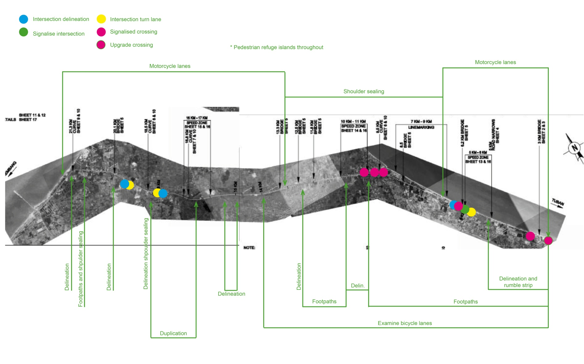
Sources: Site CRI-17 Implementation Document; iRAP Online Software.

How the approaches fit together
The iRAP assessments and CRI are highly complementary. They (and Road Safety Audits) are both necessary elements of a comprehensive approach to infrastructure safety.
iRAP assessments can:
- provide a means of identifying the scale of investment and work necessary to reduce risk across an entire road corridor or a network. As such, they can be used as a guide on the number of CRI that might be necessary to refine road improvement recommendations.
- help target CRI to locations that present the highest risk for vehicle occupants, motorcyclists, pedestrians and/or bicyclists.
- help focus the CRI investigations on key road attributes, such as a lack of footpath provision in areas of high pedestrian activity, and countermeasures that are likely to generate the largest economic returns.

The iRAP Road Protection Score and Star Rating Demonstrator also provides a means of quantifying the potential reduction in risk associated with recommendations made in the CRI.

CRI can:
- improve upon the iRAP recommendations at specific locations by investigating detailed, site-specific issues
- transform the generalised iRAP recommendations into detailed design recommendations, ready for implementation.

The results of iRAP assessments are available in the online software. This includes Road Protection Scores, Star Ratings, Detailed Condition Reports and Safer Roads Investment Plans, for each 100 metre of road or for aggregated sections. Data can be viewed in tables, interactive maps and download files. This is also accompanied by panoramic, digital images of the road at 10-20 metre intervals. As such the iRAP assessments provide an excellent base for undertaking more detailed CRI.

- Implementation of Countermeasures
In interpreting the results of this report, it is important to recognise that iRAP is designed to provide a network-level assessment of risk and cost-effective countermeasures. For this reason, implementation of the proposals in this report will ideally include the following steps:
- local examination of proposed countermeasures (including a ‘value engineering’ type workshop including all relevant stakeholders)
- preliminary scheme investigation studies
- detailed design and costing of each proposal, final evaluation and then construction.

The Crash Reduction Investigations (CRI) which have been undertaken by IndII and are discussed in Section 7 of this report provide an excellent basis for transforming iRAP recommendations into designs and construction.

The detailed results of the project and online software that enabled the iRAP analyses to be undertaken have been made available to stakeholders for further exploration and use. The Road Safety Toolkit (http://toolkit.irap.org) provides additional information on road safety issues and countermeasures.

In the following sections, some key issues that should be taken into consideration during the implementation process are discussed.

Roadside hazards
Removing roadside hazards is the most effective countermeasure identified in this report, and is recommended for about half of the road (440km carriageway kilometres). However, it is recognised that the feasibility of opening clear zones when they are occupied by buildings is a challenging subject, and overlaps with land acquisition policies. Moreover, few roadside safety barriers were recommended in the plan because of the high motorcyclist volume on the roads. At this point in time, it is not clear that motorcycle-friendly safety barriers could feasibly be installed widely in Indonesia.

Further work is required to refine the recommendations for roadside hazard removal, develop a process to enable roadside hazard removal implementation and/or investigate the possibility of motorcycle-friendly safety barriers being used.

Pedestrian crossings
The installation of new pedestrian crossings is economically feasible across a large length of the corridor. The majority of crossings identified are pedestrian refuges and signalised crossings. In many locations, it may be feasible to consider creating extended stretches of road which have a continuous pedestrian refuges / medians in place.

Further, it is noted that there are 274 marked unsignalised pedestrian crossings on the corridor. Generally, these ‘zebra’ crossings do not operate according to their original design, which is for vehicles to give way to pedestrians using the crossing. It is recommended that the use of zebra crossings in Indonesia is reviewed with a view to supporting their correct use or supplementing them with infrastructure improvements to slow passing vehicles.

Motorcycles
A clear challenge for safety on Jalan Lintas Pantura Jawa is motorcycle safety. Given that motorcycles account for a large percentage of all traffic and deaths, careful consideration needs to be given to the way in which infrastructure is developed. Motorcycle lanes have been identified as being economically feasible for 150km of Jalan Lintas Pantura Jawa.

In Malaysia, exclusive and inclusive motorcycle lanes have been used successfully and, importantly, a body of knowledge about their safe application is being developed. The experience in Malaysia should be reviewed prior to construction of motorcycle lanes.

Figure 19: Exclusive motorcycle lanes have been used to good effect in Malaysia

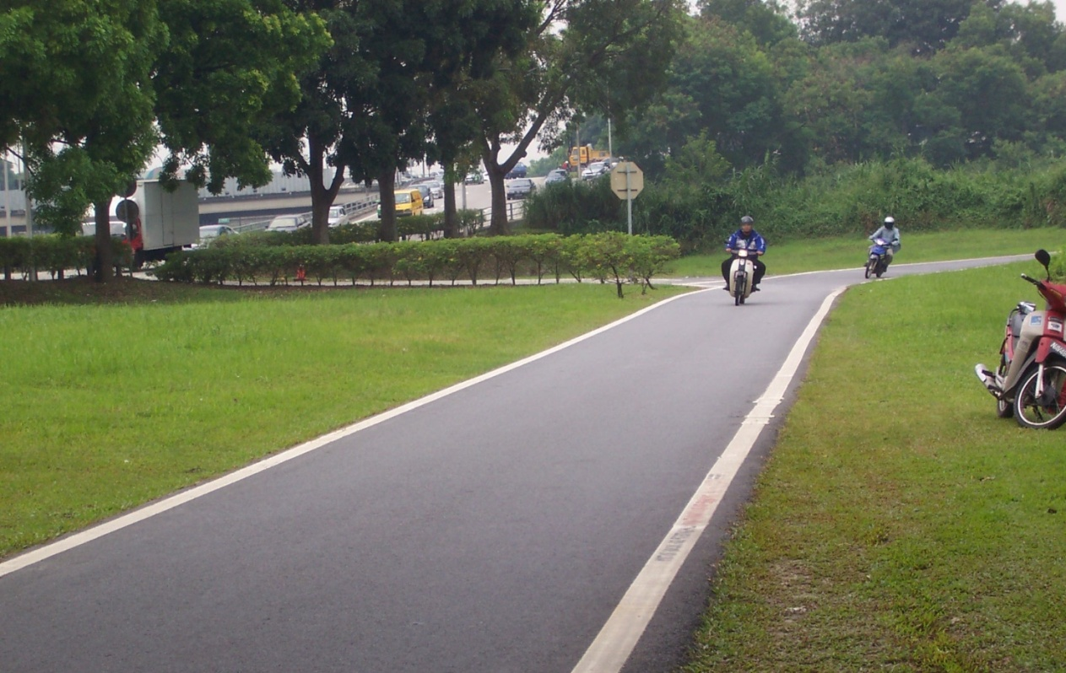

Speed management
The issue of speed management is particularly important in road safety. Traffic speeds also have a significant bearing on the iRAP Star Ratings. As such, it warrants special attention in this report.

The risk of death or serious injury is minimised in any crash, where:
- vulnerable road users (e.g. motorcyclists, bicyclists and pedestrians) are physically separated from cars and heavier vehicles, or traffic speeds are 40km/h or less
- opposing traffic is physically separated and roadside hazards are well managed
- traffic speeds are 70km/h or less for occupants of cars on roads where opposing traffic is not physically separated or roadside hazards exist.

An issue that has emerged during iRAP’s assessments in some countries is a discrepancy between permitted (posted) speeds and the speeds at which vehicles actually travel. In some locations posted speed limits are set at very low speeds, and are unlikely to be complied with without continuous enforcement or robust traffic calming measures.

As discussed in Section 3.5 of this report, the Star Ratings herein are based on estimated operating speeds (50km/h in urban areas and 70km/h in rural areas). However, it is possible that traffic operates at faster speeds and as a result, the iRAP model may underestimate the casualties and the associated countermeasure benefits on roads where typical speeds are in excess of the estimated operating speed limit. Moreover, worthwhile traffic calming countermeasures may not be triggered, even though they may offer good investment returns.

To provide a sense of the impact of varying travel speeds, two additional analyses were undertaken. The first examined the impact on overall Star Ratings of increasing operating speeds by 10km/h and reducing operating speeds by 10km/h (see Figure 20).This showed that if speeds are increased by 10km/h, the percentage of roads in the 1- and 2-star category increases from 43% to 59%. If speeds are reduced by 10km/h, the percentage of roads in the 1- and 2-star category decreases from 43% to 18%.

Figure 20: Motorcyclist Star Ratings with different travel speeds
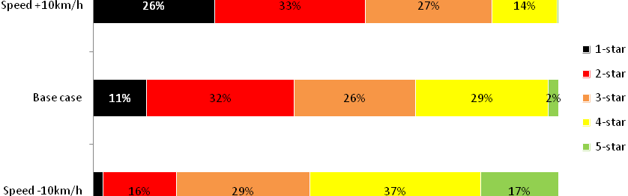
The second analysis focused on a single 100m section of road (as shown in Figure 21). In addition to changes in speed, the effect of changing a limited number of road attributes was also tested. Overall, the variables tested were:
- speed
- addition of roadside safety barriers (replacing fixed objects 0-5m from the road)
- horizontal realignment from moderate curvature to straight
- replacing the centreline with a median barrier.

The results of the testing are shown below in Figure 22.

Figure 21: The 100m sample road
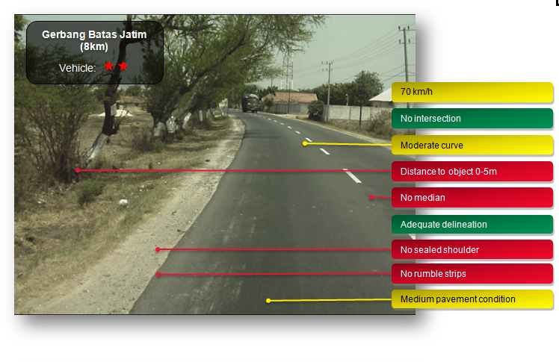
Figure 22: Changes in RPS and Star Ratings as a result of design and speed changes for the section of road shown in Figure 21

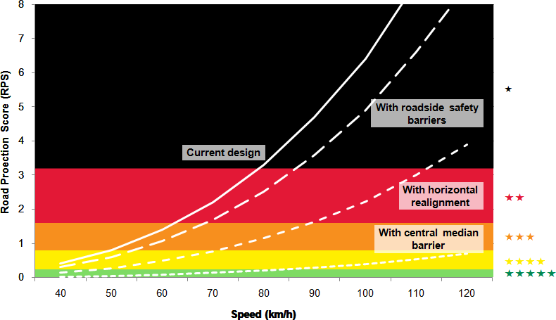

The test illustrates the degree to which risk increases as speed does too on this single section of road. This results in the Star Ratings declining. They also show that the increase in risk associated with increases in speed may be offset by the addition of mid block attributes. For example, with the road operating at 70km/h it has a 2-star rating. However, if traffic were found to be travelling 80km/h, then it would be rated 1-star. Alternatively, if traffic were travelling at 60km/h, the road would be 3-stars. It is possible to have traffic operating at 120km/h and improve the Star Rating 4-star rating, as long as roadside and median safety barriers are installed and horizontal alignment is improved. Alternatively the addition of these attributes with no change in speed zone would result in an improvement to 5-stars.
These two analyses indicate the degree to which risk is sensitive to speeds.

In order to ensure that Star Rating results reflect the speeds actually travelled and that the most appropriate countermeasures are triggered, further research may be possible for Indonesia to measure speeds. Once the broad shape of an investment plan has been agreed, it is necessary for travelled speed profiles to become part of the detailed project planning and site assessments.

In terms of speed management more broadly, the raw condition data collected as part of the iRAP process will provide a valuable resource to authorities investigating appropriate speed management initiatives. This may include a more detailed analysis of results to investigate where there are lower speed limits without accompanying engineering solutions, or may include a review of the speed limits and facilities in place on roads that rate poorly for pedestrian or bicycle safety.

The iRAP results therefore should help enable a professional discussion between Police and highway authorities about their goals and respective roles in enforcement and engineering so each can contribute best to ensuring safe speeds. It is for Indonesia’s stakeholders to decide if and when a national debate which educates the public about the importance of speed limits should occur. Clearly such a debate is likely to make more sense if launched alongside a major program of safety engineering improvements with emphasis on safe driving, safe vehicles and safe roads.

A Safe System
In order to make Jalan Lintas Pantura Jawa safer, efforts that go beyond traditional engineering to ensure that planning and design is integrated with an appreciation of local road user behaviour will be necessary. For example, research has demonstrated that it is crucial to ensure that local communities have the opportunity to both contribute to road designs but also have access to education so that they can understand the intended use of various road design features (BRAC, 2009). This issue is especially important in relation to pedestrian safety. Ensuring that pedestrians choose safe crossing points (such as pedestrian overpasses) when they are available is especially important. Efforts have been made around the world to manage this through the use of pedestrian fences, although anecdotal evidence suggests that the effectiveness of this is mixed, with people jumping over fences or, in some cases, stealing them. Innovative approaches may be needed to address these issues.

In addition to taking a more comprehensive approach to road safety engineering, significant benefits could be realised through coordinated targeting risk factors for road users (such as speeding, seat belt wearing and alcohol) and vehicles. This would be consistent with taking a Safe System approach to the programme. The Road Safety Toolkit (toolkit.irap.org) and United Nations Road Safety Collaboration Good Practice Manuals (WHO, 2009) provide further information on this issue.

Data
A key challenge in a project such as this is securing reliable traffic, crash and countermeasure cost data. As part of the implementation process, traffic volume and crash data collection for a before-and-after evaluation of the improvements, that will demonstrate their success and enable a second-phase improvement programme for the next investment period to be developed, should be collected. The recently released Good Practice Manual (2010) on data provides guidance on this issue.

- Road Survey Data Quality Review

Data provided by: Institute of Road Engineering (IRE), Directorate General of Highways (DGH)
Review date: 25 May 2011
Reviewed by: Greg Smith, Regional Director, iRAP Asia Pacific
Advice by: Richard Wix, Principal Consultant, ARRB Group
Assessment: Data satisfactory for demonstration project, but improvements suggested for future assessments

Background
For the purposes of the iRAP Indonesia Demonstration Project, previously collected road survey data for Jalan Lintas Pantura Jawa (North Coast Corridor) in Java was provided by the Directorate General of Highways (DGH) Institute of Road Engineering (IRE). The data was collected using an ARRB Group Hawkeye system which is accredited by iRAP.

Although digital images have been captured with two cameras only (as opposed the three, which is the iRAP preference), and an initial review of the data by the ARRB Group coding team showed that this was sufficient for the demonstration project.

However, the team also identified a number of areas where the data collection could be improved for future iRAP assessments.

Data Quality Assessment
Item | Description of mandatory requirements | Description of finding | = Good  X = Area for improvement
1 | Minimum resolution of digital images 1280 x 960 pixels | Sufficient resolution.
2 | 160 to 180° field of view | Two cameras were used (driver and passenger). The inclusion of a third forward facing camera to give a better panoramic view of the road would make a dramatic improvement to the coding task. | X
3 | Ability to code at 100m intervals and view images at a minimum of 20m intervals | Images supplied at 10m and 20m intervals. Data compatible with ARRB Hawkeye Processing Toolkit.
4 | Continuous and accurate geo-referencing | Approximately 840km out of 1000km of data provided could be coded. The data set contained bad surveys. This includes:  - Runs that had been aborted just after the start and runs that only contained one reference point.  - In some instances the imaging data was missing and on other occasions the geometry data couldn’t be processed because there wasn’t enough lead-in data. | X
5 | The exact start and end points for road sections shall be determined by the consultant in conjunction with iRAP and the road authority. | The naming convention for survey files and location referencing was not consistent with the IRMS database used by Bina Marga. As a result, combining the survey data set with the traffic volume data set was challenging | X
6 | Measurement calibration | The images had been calibrated for on-screen measurements, although it is difficult to comment on the accuracy of the calibrations except to say that the measurements appear to be reasonable. Proper documentation of the calibration process used for collection of the survey data would improve certainty about the measurements. | X
7 | Images supplied in suitable electronic format | Images supplied in Hawkeye format.
8 | Clear (unobstructed) forward visibility | - There were instances where the survey data had continued to be collected once the lighting conditions become poor in the late-afternoon, meaning road attributes were not sufficiently visible for coding.  - There were instances the images were too bright, meaning road attributes were not sufficiently visible for coding.  - On some runs, the images are blurred.  - There are numerous instances where the images are unstructured by close following of trucks. | X
9 | Safe operation of survey vehicle | The survey images indicate that many risky manoeuvres were made by the survey vehicle, especially when passing slower vehicles. It appears that the survey vehicle may have exceeded speed limits. | X
10 | Images from rear-facing camera (optional) | Rear cameras not available. | X
11 | Capability to provide automated measurements of radius of curvature for horizontal curves and percent grade for vertical grades (optional) | Not available. | X
12 | Capability to measure traffic speeds and traffic volumes on the roads while undertaking the inspection (optional) | Not available. | X

Example Images
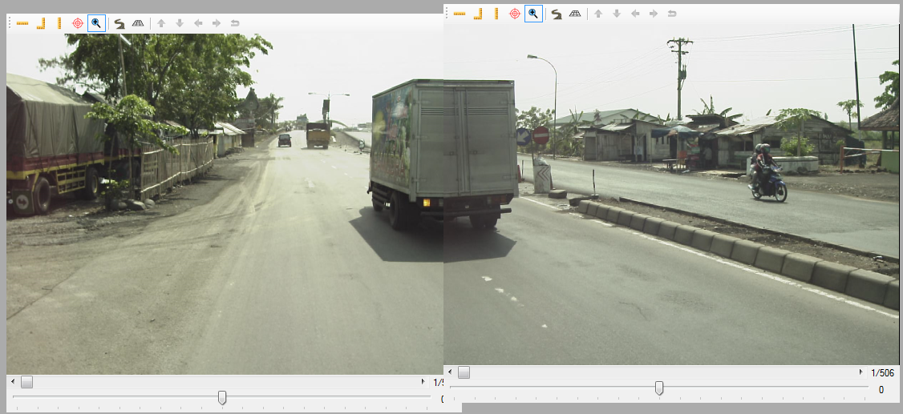
Satisfactory images (file: 05-24-004-1-Pemalang-Batas Kota (PKLTimur))

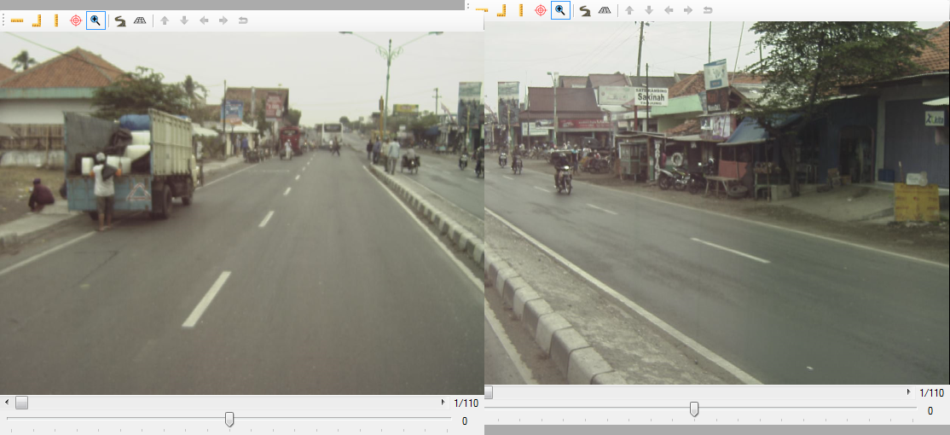
Blured images (file: 01-24-001-Pejagan-Losari)
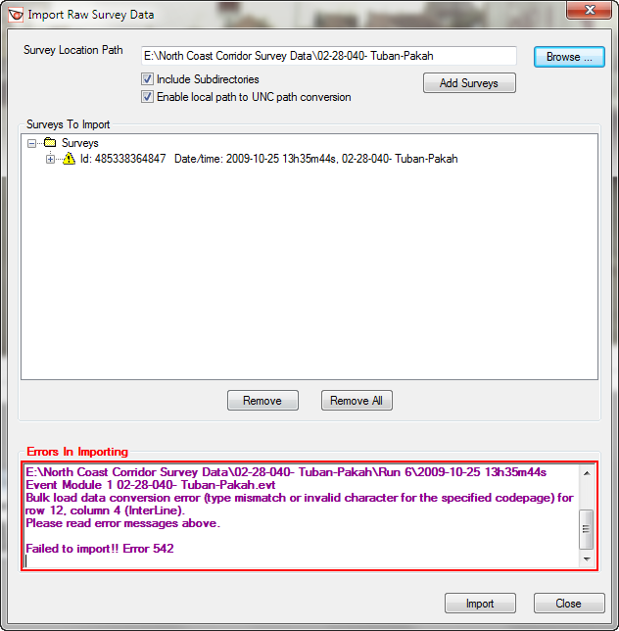
File unable to be imported (file: 02-28-040- Tuban-Pakah)

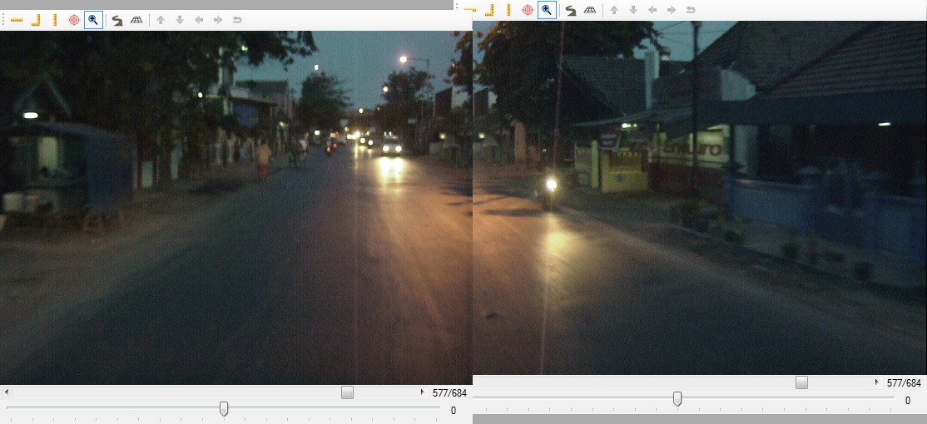
Images too dark (file: 10-28-043-11-K-Jl Raya Gresik(Surabaya))

Recommendation for Training
ARRB Group recommended that the survey team at the Institute of Road Engineering would benefit from training in:
- system calibration
- survey planning
- data collection techniques
- data handling.

- iRAP Road Attributes

Attribute | Category
Road Name | Text
Section | Text
Carriageway | Carriageway A of a divided carriageway road
 | Carriageway B of a divided carriageway road
 | Undivided road / single carriageway road
Distance | Number
Length | Number
Latitude | Number
Longitude | Number
Landmark | Text
Traffic Flow | Number
Motorcycle Percent | 100%
 | 81% - 99%
 | 61% - 80%
 | 41% - 60%
 | 21% - 40%
 | 11% - 20%
 | 6% - 10%
 | 1% - 5%
 | 0%
 | Not recorded
Bicycle Flow | High
 | Medium
 | Low
 | Not recorded / None
Pedestrian Flow - Crossing Road | High
 | Medium
 | Low
 | Not recorded / None
Pedestrian Flow - Along Road | High
 | Medium
 | Low
 | Not recorded / None
Area Type | Urban
 | Semi-urban
 | Rural
Number of lanes for use by through traffic | Four or more
 | Three
 | Two
 | One
One way / two way flow | One way traffic
 | Two way traffic
Speed | > = 120km/h
 | 110km/h
 | 100km/h
 | 90km/h
 | 80km/h
 | 70km/h
 | 60km/h
 | 50km/h
 | <= 40km/h
Lane width for lanes serving through traffic | Narrow
 | Medium
 | Wide
Paved Shoulder width | None
 | Paved 0< Width<=1m
 | Paved 1< Width < 2.4m
 | Paved >= 2.4m
Unpaved Shoulder width | None
 | Unpaved 0< Width<=1m
 | Unpaved 1< Width < 2.4m
 | Unpaved >= 2.4m
Shoulder Rumble Strip | No
 | Yes
Curvature | Very sharp
 | Sharp curve
 | Moderate curvature
 | Straight or gently curving
Quality of curve | Poor
 | Adequate
Overtaking demand | High
 | Medium
 | Low
 | None
Delineation | Poor
 | Adequate
Vertical Alignment Variation | Significant crests and dips
 | Undulating / Rolling
 | Flat
Road Condition | Poor
 | Medium
 | Good
Sidewalk Provision - left | None
 | Adjacent to traffic
 | Non-physical separation > 1m ≤ 3m
 | Non-physical separation >3m
 | Physical barrier
 | NOT RECORDED
Sidewalk Provision - right | None
 | Adjacent to traffic
 | Non-physical separation > 1m ≤ 3m
 | Non-physical separation >3m
 | Physical barrier
 | NOT RECORDED
Land use - left | Commercial
 | Residential
 | Development other than residential or commercial
 | Undeveloped areas
 | Not Recorded
Land use - right | Commercial
 | Residential
 | Development other than residential or commercial
 | Undeveloped areas
 | Not Recorded
Side friction | High
 | Medium
 | Low
Pedestrian crossing facilities | Refuge only
 | Unsignalised marked crossing without a refuge
 | Unsignalised marked crossing with refuge
 | Signalised without refuge
 | Signalised with refuge
 | Grade separated facility
 | No facility
Pedestrian Crossing - Quality | Poor
 | Adequate
 | Not Applicable
Facilities for bicycles | None
 | Dedicated Bicycle Lane on roadway
 | Segregated Bicycle Path
 | Segregated Bicycle Path with barrier
Roadside Severity - Segregated Bicycle Path | Cliff
 | Distance to object 0-5 m
 | Steep fill embankment slopes
 | Deep drainage ditches
 | Distance to object 5-10 m
 | Cut
 | Safety barrier
 | Motorcyclist friendly barrier
 | Distance to object >10m
 | Not recorded
Facilities for motorised two wheelers | None
 | Dedicated Motorcycle Lane on roadway
 | Segregated two-way motorcycle path WITHOUT barrier
 | Segregated two-way motorcycle path WITH barrier
 | Segregated one-way motorcycle path WITHOUT barrier
 | Segregated one-way motorcycle path WITH barrier
Roadside Severity - Segregated Motorcycle Path | Cliff
 | Distance to object 0-5 m
 | Steep fill embankment slopes
 | Deep drainage ditches
 | Distance to object 5-10 m
 | Cut
 | Safety barrier
 | Motorcyclist friendly barrier
 | Distance to object >10m
 | Not recorded
Speed - Segregated Motorcycle Path | 120km/h
 | 110km/h
 | 100km/h
 | 90km/h
 | 80km/h
 | 70km/h
 | 60km/h
 | 50km/h
 | <= 40km/h
Median Type - Segregated Motorcycle Path | Centre line only
 | Continuous central turning lane
 | Central hatching
 | Rumble strip
 | Physical median width up to 1m
 | Physical median width 1-5m
 | Physical median width 5-10m
 | Physical median width 10-20m
 | High quality barrier
 | Motorcyclist friendly barrier
 | Physical median width >20m
 | Not Applicable (e.g. one way road)
Minor Access Point Density | High Density
 | Low Density
 | Not Applicable (rural area)
Roadside Severity - left hand side | Cliff
s | Distance to object 0-5 m
 | Steep fill embankment slopes
 | Deep drainage ditches
 | Distance to object 5-10 m
 | Cut
 | Safety barrier
 | Motorcyclist friendly barrier
 | Distance to object >10m
 | Not recorded (urban low speed area)
Roadside Severity - right hand side | Cliff
 | Distance to object 0-5 m
 | Steep fill embankment slopes
 | Deep drainage ditches
 | Distance to object 5-10 m
 | Cut
 | Safety barrier
 | Motorcyclist friendly barrier
 | Distance to object >10m
 | Not recorded (urban low speed area)
Major Intersection type- likelihood | 4-leg (unsignalised) no right turn lane
 | 4-leg (unsignalised) right turn lane
 | 4-leg (signalised) no right turn lane
 | 3-leg (unsignalised) no right turn lane
 | Railway Crossing - Passive (signs only)
 | 4-leg (signalised) right turn lane
 | 3-leg (unsignalised) right turn lane
 | 3-leg (signalised) no right turn lane
 | 3-leg (signalised) right turn lane
 | Roundabout (low speed)
 | Merge Lane (short slip)
 | Merge Lane (no slip)
 | Roundabout (high speed)
 | Railway Crossing - Active (flashing lights / boom gates)
 | Merge Lane (long slip)
 | Median Crossing Point - Poor condition
 | Median Crossing Point - Good condition
 | Minor Junctions
 | none
Intersection quality | poor
 | good
 | not applicable
Intersecting Road Volume | High >= 10,000
 | Medium >= 1,000 to < 10,000
 | Low < 1,000
 | Not recorded / unknown
Median Type | Centre line only
 | Central hatching
 | Rumble strip
 | Continuous central turning lane
 | Physical median width up to 1m
 | Physical median width 1-5m
 | Physical median width 5-10m
 | Motorcyclist friendly barrier
 | Physical median width 10-20m
 | High quality barrier
 | Physical median width >20m
 | Not Applicable (e.g. one way road)
Major Upgrade Cost Impact | High
 | Medium
 | Low
Comments | Comments
Roadworks | Road works in progress
 | No road works

- Countermeasure Costs

The following table list estimated countermeasure costs used in the economic analysis. Estimates are categorised according countermeasure type, area type and cost. These costs may be reviewed by IndII and DGH prior to detailed feasibility and design.

Countermeasure | Countermeasure User Group | Service Life | Unit of Cost | Cost - Urban |  |  | Cost - Semi-urban |  |  | Cost - Rural
 |  |  |  | Low Upgrade Cost | Med Upgrade Cost | High Upgrade Cost | Low Upgrade Cost | Med Upgrade Cost | High Upgrade Cost | Low Upgrade Cost | Med Upgrade Cost | High Upgrade Cost
Improve delineation | Vehicle | 5 | lane km | 4,000,000 | 6,000,000 | 7,000,000 | 3,500,000 | 5,000,000 | 6,000,000 | 3,000,000 | 4,000,000 | 5,000,000
Bicycle lane (on-road) | Cyclists | 20 | per km (serving both directions) | 4,000,000 | 5,000,000 | 6,000,000 | 3,000,000 | 4,000,000 | 5,000,000 | 2,000,000 | 3,000,000 | 4,000,000
Bicycle lane (off-road) | Cyclists | 20 | per km (serving both directions) | 569,140,037 | 626,054,040 | 682,968,044 | 455,312,029 | 569,140,037 | 626,054,040 | 409,780,826 | 523,608,834 | 569,140,037
Motorcycle lane (painted logos only on-road) | Motorcyclists | 5 | per km (serving both directions) | 5,000,000 | 7,000,000 | 8,000,000 | 4,000,000 | 6,000,000 | 7,000,000 | 3,000,000 | 5,000,000 | 6,000,000
Motorcycle lane (construct on-road) | Motorcyclists | 20 | per km (serving both directions) | 350,000,000 | 600,000,000 | 750,000,000 | 300,000,000 | 500,000,000 | 600,000,000 | 250,000,000 | 400,000,000 | 500,000,000
Motorcycle lane (segregated) | Motorcyclists | 20 | per km (serving both directions) | 750,000,000 | 950,000,000 | 1,200,000,000 | 700,000,000 | 800,000,000 | 1,000,000,000 | 600,000,000 | 750,000,000 | 900,000,000
Horizontal realignment | Vehicle | 20 | lane km | 2,500,000,000 | 3,250,000,000 | 4,000,000,000 | 2,000,000,000 | 3,000,000,000 | 3,500,000,000 | 1,750,000,000 | 2,650,000,000 | 3,000,000,000
Improve curve delineation | Vehicle | 5 | per carriageway km | 9,000,000 | 11,000,000 | 13,000,000 | 8,000,000 | 9,000,000 | 11,000,000 | 6,000,000 | 8,000,000 | 10,000,000
Lane widening (up to 0.5m) | Vehicle | 10 | lane km | 350,000,000 | 600,000,000 | 750,000,000 | 300,000,000 | 500,000,000 | 600,000,000 | 250,000,000 | 400,000,000 | 500,000,000
Lane widening (>0.5m) | Vehicle | 10 | lane km | 750,000,000 | 950,000,000 | 1,200,000,000 | 700,000,000 | 800,000,000 | 1,000,000,000 | 600,000,000 | 750,000,000 | 900,000,000
Right turn lane (unsignalised 3 leg) | Vehicle | 10 | intersection | 700,000,000 | 800,000,000 | 900,000,000 | 600,000,000 | 700,000,000 | 800,000,000 | 500,000,000 | 600,000,000 | 700,000,000
Right turn lane (unsignalised 4 leg) | Vehicle | 10 | intersection | 1,250,000,000 | 1,750,000,000 | 2,000,000,000 | 1,000,000,000 | 1,500,000,000 | 1,750,000,000 | 900,000,000 | 1,200,000,000 | 1,500,000,000
Delineation and signing (intersection) | Vehicle | 5 | intersection | 2,250,000,000 | 2,750,000,000 | 3,000,000,000 | 2,000,000,000 | 2,500,000,000 | 2,750,000,000 | 1,750,000,000 | 2,200,000,000 | 2,500,000,000
Right turn provision at existing signalised site (3-leg) | Vehicle | 10 | intersection | 1,000,000,000 | 1,500,000,000 | 1,750,000,000 | 900,000,000 | 1,250,000,000 | 1,500,000,000 | 750,000,000 | 1,000,000,000 | 1,250,000,000
Right turn provision at existing signalised site (4-leg) | Vehicle | 10 | intersection | 1,500,000,000 | 2,000,000,000 | 2,500,000,000 | 1,000,000,000 | 1,750,000,000 | 2,000,000,000 | 1,000,000,000 | 1,500,000,000 | 1,750,000,000
Signalise intersection (3-leg) | All | 20 | intersection | 1,300,000,000 | 1,950,000,000 | 2,275,000,000 | 1,170,000,000 | 1,625,000,000 | 1,950,000,000 | 975,000,000 | 1,300,000,000 | 1,625,000,000
Signalise intersection (4-leg) | All | 20 | intersection | 1,950,000,000 | 2,600,000,000 | 3,250,000,000 | 1,300,000,000 | 2,275,000,000 | 2,600,000,000 | 1,300,000,000 | 1,950,000,000 | 2,275,000,000
Grade separation | All | 50 | intersection | 2,750,000,000 | 3,500,000,000 | 3,750,000,000 | 2,500,000,000 | 3,250,000,000 | 3,600,000,000 | 2,250,000,000 | 3,000,000,000 | 3,500,000,000
Rail crossing upgrade | Vehicle | 20 | intersection | 2,250,000,000 | 3,000,000,000 | 3,500,000,000 | 2,000,000,000 | 2,750,000,000 | 3,250,000,000 | 1,750,000,000 | 2,500,000,000 | 3,000,000,000
Roundabout | Vehicle | 20 | intersection | 2,750,000,000 | 3,500,000,000 | 4,000,000,000 | 2,500,000,000 | 3,250,000,000 | 3,500,000,000 | 2,000,000,000 | 3,000,000,000 | 3,250,000,000
Central hatching | All | 10 | per km (serving both directions) | 5,333,333 | 5,666,667 | 6,000,000 | 4,666,667 | 5,333,333 | 5,666,667 | 4,333,333 | 5,000,000 | 5,333,333
Rumble strip / flexi-post | Vehicle | 10 | per km (serving both directions) | 3,500,000 | 4,000,000 | 5,000,000 | 3,250,000 | 3,750,000 | 4,000,000 | 3,000,000 | 3,600,000 | 3,750,000
Central turning lane full length | Vehicle | 10 | per km (serving both directions) | 4,000,000 | 4,250,000 | 4,500,000 | 3,500,000 | 4,000,000 | 4,250,000 | 3,250,000 | 3,750,000 | 4,000,000
Central median barrier (no duplication) | Vehicle | 10 | per km (serving both directions) | 313,050,013 | 417,400,018 | 521,750,022 | 260,875,011 | 365,225,016 | 417,400,018 | 208,700,009 | 313,050,013 | 365,225,016
Duplication with median barrier | Vehicle | 20 | per carriageway km | 2,385,142,721 | 2,782,666,508 | 3,180,190,295 | 2,186,380,828 | 2,583,904,615 | 2,782,666,508 | 1,987,618,934 | 2,385,142,721 | 2,583,904,615
Duplicate - <1m median | All | 20 | per carriageway km | 2,226,133,206 | 2,782,666,508 | 3,339,199,810 | 1,947,866,556 | 2,504,399,857 | 2,782,666,508 | 1,669,599,905 | 2,226,133,206 | 2,504,399,857
Duplicate - 1-5 m median | All | 20 | per carriageway km | 2,226,133,206 | 2,782,666,508 | 3,339,199,810 | 1,808,733,230 | 2,504,399,857 | 2,782,666,508 | 1,669,599,905 | 2,226,133,206 | 2,504,399,857
Duplicate - 5-10m median | All | 20 | per carriageway km | 2,946,353,068 | 3,339,200,143 | 3,928,470,757 | 2,357,082,454 | 2,749,929,530 | 3,142,776,606 | 1,964,235,379 | 2,357,082,454 | 2,749,929,530
Duplicate - 10-20m median | All | 20 | per carriageway km | 3,547,900,152 | 4,174,000,179 | 5,008,800,215 | 3,130,500,135 | 3,756,600,161 | 4,174,000,179 | 2,713,100,117 | 3,339,200,143 | 3,756,600,161
Duplicate - >20m median | All | 20 | per carriageway km | 3,673,120,158 | 5,008,800,215 | 5,843,600,251 | 3,005,280,129 | 4,007,040,172 | 5,008,800,215 | 2,671,360,115 | 3,339,200,143 | 4,174,000,179
Service Road | All | 20 | per km (serving both directions) | 2,500,000,000 | 3,000,000,000 | 3,500,000,000 | 2,250,000,000 | 2,750,000,000 | 3,000,000,000 | 2,000,000,000 | 2,500,000,000 | 2,750,000,000
Additional lane | Vehicle | 20 | per km (serving both directions) | 3,000,000,000 | 3,500,000,000 | 3,800,000,000 | 2,750,000,000 | 3,250,000,000 | 3,500,000,000 | 2,500,000,000 | 3,000,000,000 | 3,250,000,000
Implement one way network | All | 20 | per carriageway km | 3,000,000,000 | 3,250,000,000 | 3,500,000,000 | 2,500,000,000 | 3,000,000,000 | 3,250,000,000 | 2,250,000,000 | 2,750,000,000 | 3,000,000,000
Upgrade existing pedestrian facilities | Pedestrian | 10 | unit | 175,000,000 | 200,000,000 | 250,000,000 | 150,000,000 | 175,000,000 | 200,000,000 | 125,000,000 | 150,000,000 | 175,000,000
Refuge Island | Pedestrian | 10 | unit | 200,000,000 | 250,000,000 | 300,000,000 | 175,000,000 | 200,000,000 | 250,000,000 | 150,000,000 | 175,000,000 | 200,000,000
Unsignalised crossing | Pedestrian | 10 | unit | 1,250,000,000 | 1,500,000,000 | 1,750,000,000 | 1,000,000,000 | 1,250,000,000 | 1,500,000,000 | 750,000,000 | 1,000,000,000 | 1,250,000,000
Signalised crossing | Pedestrian | 20 | unit | 1,500,000,000 | 1,750,000,000 | 2,000,000,000 | 1,250,000,000 | 1,500,000,000 | 1,750,000,000 | 1,000,000,000 | 1,300,000,000 | 1,500,000,000
Grade separated pedestrian facility | Pedestrian | 50 | unit | 1,000,000,000 | 1,250,000,000 | 1,500,000,000 | 750,000,000 | 1,000,000,000 | 1,250,000,000 | 600,000,000 | 850,000,000 | 1,000,000,000
Road surface improvement | Vehicle | 10 | lane km | 1,600,000,000 | 1,800,000,000 | 2,000,000,000 | 1,250,000,000 | 1,500,000,000 | 1,750,000,000 | 1,100,000,000 | 1,400,000,000 | 1,600,000,000
Road resurface | Vehicle | 10 | lane km | 800,000,000 | 1,000,000,000 | 1,250,000,000 | 600,000,000 | 800,000,000 | 1,000,000,000 | 500,000,000 | 700,000,000 | 900,000,000
Clear roadside hazards (trees, poles, structures) - Left | Vehicle | 20 | per linear km | 25,623,000 | 170,820,000 | 2,562,300,000 | 25,623,000 | 170,820,000 | 2,562,300,000 | 23,060,700 | 153,738,000 | 2,306,070,000
Clear roadside hazards (trees, poles, structures) - Right | Vehicle | 20 | per linear km | 25,623,000 | 170,820,000 | 2,562,300,000 | 25,623,000 | 170,820,000 | 2,562,300,000 | 23,060,700 | 153,738,000 | 2,306,070,000
Sideslope improvement - Left | Vehicle | 20 | per linear km | 75,000,000 | 85,000,000 | 100,000,000 | 50,000,000 | 75,000,000 | 90,000,000 | 40,000,000 | 50,000,000 | 75,000,000
Sideslope improvement - Right | Vehicle | 20 | per linear km | 75,000,000 | 85,000,000 | 100,000,000 | 50,000,000 | 75,000,000 | 90,000,000 | 40,000,000 | 50,000,000 | 75,000,000
Roadside barriers - Left | Vehicle | 20 | per linear km | 1,000,000,000 | 1,250,000,000 | 1,500,000,000 | 850,000,000 | 1,000,000,000 | 1,250,000,000 | 650,000,000 | 800,000,000 | 1,000,000,000
Roadside barriers - Right | Vehicle | 20 | per linear km | 1,000,000,000 | 1,250,000,000 | 1,500,000,000 | 850,000,000 | 1,000,000,000 | 1,250,000,000 | 650,000,000 | 800,000,000 | 1,000,000,000
Shoulder sealing (<1m) | Vehicle | 20 | per carriageway km | 18,000,000 | 20,000,000 | 22,500,000 | 15,000,000 | 18,000,000 | 20,000,000 | 12,000,000 | 15,000,000 | 18,000,000
Shoulder sealing (>1m) | All | 20 | per carriageway km | 40,000,000 | 45,000,000 | 50,000,000 | 35,000,000 | 40,000,000 | 45,000,000 | 30,000,000 | 35,000,000 | 40,000,000
Unsealed shoulder (<1m) | Vehicle | 10 | per carriageway km | 150,000,000 | 175,000,000 | 200,000,000 | 130,000,000 | 160,000,000 | 180,000,000 | 120,000,000 | 150,000,000 | 170,000,000
Unsealed shoulder (>1m) | All | 10 | per carriageway km | 250,000,000 | 300,000,000 | 350,000,000 | 225,000,000 | 275,000,000 | 300,000,000 | 200,000,000 | 250,000,000 | 275,000,000
Parking improvements | Vehicle | 10 | per km (serving both directions) | 38,261,668 | 41,740,002 | 45,218,335 | 34,783,335 | 38,261,668 | 41,740,002 | 31,305,001 | 34,783,335 | 38,261,668
Restrict/combine direct access points | All | 10 | per km (serving both directions) | 37,945,456 | 41,740,002 | 45,534,547 | 30,356,365 | 37,945,456 | 41,740,002 | 26,561,819 | 30,356,365 | 37,945,456
Regulate roadside commercial activity | All | 10 | per km (serving both directions) | 33,392,001 | 41,740,002 | 45,914,002 | 29,218,001 | 37,566,002 | 41,740,002 | 25,044,001 | 33,392,001 | 37,566,002
Footpath provision (adjacent to road) | Pedestrian | 20 | per km (serving both directions) | 521,750,022 | 626,100,027 | 730,450,031 | 417,400,018 | 521,750,022 | 626,100,027 | 333,920,014 | 417,400,018 | 521,750,022
Footpath provision (separated from road) | Pedestrian | 20 | per km (serving both directions) | 569,140,037 | 626,054,040 | 682,968,044 | 455,312,029 | 569,140,037 | 626,054,040 | 409,780,826 | 523,608,834 | 569,140,037
Traffic calming | All | 10 | per carriageway km | 600,000,000 | 750,000,000 | 900,000,000 | 500,000,000 | 600,000,000 | 750,000,000 | 400,000,000 | 500,000,000 | 600,000,000
Vertical realignment (minor) | All | 20 | lane km | 1,500,000,000 | 1,750,000,000 | 2,000,000,000 | 1,250,000,000 | 1,500,000,000 | 1,750,000,000 | 1,000,000,000 | 1,250,000,000 | 1,500,000,000
Vertical realignment (major) | All | 20 | lane km | 3,000,000,000 | 3,250,000,000 | 3,500,000,000 | 2,750,000,000 | 3,000,000,000 | 3,250,000,000 | 2,500,000,000 | 2,750,000,000 | 3,000,000,000
Overtaking lane | Vehicle | 20 | per linear km | 3,250,000,000 | 3,500,000,000 | 3,750,000,000 | 3,000,000,000 | 3,250,000,000 | 3,500,000,000 | 2,500,000,000 | 3,000,000,000 | 3,250,000,000
Median Crossing Upgrade | Vehicle | 10 | intersection | 500,000,000 | 650,000,000 | 750,000,000 | 400,000,000 | 500,000,000 | 600,000,000 | 300,000,000 | 400,000,000 | 500,000,000
Clear roadside hazards (bike lane) | Cyclists | 20 | per km (serving both directions) | 25,623,000 | 170,820,000 | 2,562,300,000 | 25,623,000 | 170,820,000 | 2,562,300,000 | 23,060,700 | 153,738,000 | 2,306,070,000
Sideslope improvement (bike lane) | Cyclists | 20 | per km (serving both directions) | 35,000,000 | 40,000,000 | 50,000,000 | 30,000,000 | 35,000,000 | 45,000,000 | 25,000,000 | 30,000,000 | 40,000,000
Roadside barriers (bike lane) | Cyclists | 20 | per km (serving both directions) | 40,000,000 | 50,000,000 | 60,000,000 | 35,000,000 | 40,000,000 | 50,000,000 | 30,000,000 | 35,000,000 | 45,000,000
Clear roadside hazards (seg MC lane) | Motorcyclists | 20 | per km (serving both directions) | 25,623,000 | 170,820,000 | 2,562,300,000 | 25,623,000 | 170,820,000 | 2,562,300,000 | 23,060,700 | 153,738,000 | 2,306,070,000
Sideslope improvement (seg MC lane) | Motorcyclists | 20 | per km (serving both directions) | 75,000,000 | 85,000,000 | 100,000,000 | 50,000,000 | 75,000,000 | 90,000,000 | 40,000,000 | 50,000,000 | 75,000,000
Roadside barriers (seg MC lane) | Motorcyclists | 20 | per km (serving both directions) | 500,000,000 | 600,000,000 | 750,000,000 | 400,000,000 | 450,000,000 | 500,000,000 | 350,000,000 | 400,000,000 | 450,000,000
Median Barrier (seg MC lane) | Motorcyclists | 10 | per km (serving both directions) | 750,000,000 | 1,000,000,000 | 1,250,000,000 | 600,000,000 | 800,000,000 | 1,000,000,000 | 500,000,000 | 600,000,000 | 750,000,000

References

BRAC. Road Safety Public Awareness Campaign On Dhaka-Sylhet Highway Volume 1. Report for the Government of the People’s Republic of Bangladesh Ministry of Communications RRMP-III, Roads and Highways Department. Dhaka: BRAC, 2005.

Indonesia Infrastructure Initiative (2011), RSACRP Project Crash Reduction Reports, Jalan Lintas Pantura Jawa, Central, East and West Provinces.

iRAP (2009) Star Rating Roads for Safety: The iRAP Methodology. http://irap.org/library.aspx.

iRAP, gTKP, GRSF, ARRB Group (2010) Road Safety Toolkit. www.irap.org/toolkit.

McMahon, K. and Dahdah, S. (2008) The True Cost of Road Crashes: Valuing life and the cost of a serious injury. http://irap.org/library.aspx.

RAP (2009) Safer Roads Investment Plans: The iRAP Methodology. http://irap.org/library.aspx.

World Health Organisation (2009) Global Status Report on Road Safety. Time for Action.

World Health Organisation (WHO). Good Practice Manuals. Geneva: WHO. Viewed 8 February 2011. http://www.who.int/roadsafety/publications/en/.

World Health Organisation (2009) Global Status Report on Road Safety: Time for Action. http://www.who.int/violence_injury_prevention/publications/road_traffic/en/index.html
Vehicle Speeds and the iRAP Protocols provides more details on this issue. It can be downloaded at: http://irap.org/media/31613/vehicle_speeds_and_the_irap_protocols.pdf.

